

**Gamifying Carbon Footprints to Motivate Pro-Environmental Behavioural Change Through a Social Mobile Application**

Stephen Davis

B.A.(Mod.) Computer Science and Business

Final Year Project, April 2023

Supervisor: Dr. Timothy Savage

School of Computer Science and Statistics

O’Reilly Institute, Trinity College, Dublin 2, Ireland

**Declaration**

I, the undersigned, declare that this work has not previously been submitted as an exercise for a degree at this, or any other University, and that unless otherwise stated, is my own work.

____________________________________ ____________

Name Date

**Acknowledgements**

Firstly, I would like to thank Dr. Timothy Savage, for his continued support, feedback and guidance throughout the academic year. From the very beginning, deciding on the topic for this thesis, planning the workload, all the way through to delivery, Dr. Timothy Savage’s aid has been invaluable to me and to the delivery of this project.

Secondly, to friends and family who have boosted my morale during challenging times throughout my time in college. Having this support network eased the pressures experienced during my final year in college.

Finally, to participants who voluntarily participated to use the application built in this thesis, providing valuable insights and the ability to evaluate the effect of the mobile application built in this thesis.

**Abstract**

In 2021, Ireland set a target of reducing greenhouse gas emissions by 4.8%. In reality, Ireland produced an increase in greenhouse gas emissions of 5%. This example highlights the problem of a knowledge action gap towards climate change, and specifically, towards reducing individual carbon footprints.

Psychological theories such as the Inclusion Model for Environmental Concern and self-determination theory offer insights into the reasons contributing to limited societal motivation to reduce individual carbon footprints.

This thesis aims to reduce this knowledge-action gap towards reducing individual carbon footprints by building a gamified social mobile application which addresses these psychological theories. After receiving points by logging their food and transport emissions, users use these points to compete and cooperate through individual and team leaderboards, with the objective being to increase societal motivation towards reducing individual carbon footprints, thus actually reducing such footprints.

With 10 participants having trialled the application over a 7 day period, the results indicate that the gamified social mobile application effectively increased environmental motivation levels in the majority of participants, with a portion of these participants realising a reduction in their individual carbon footprints. Those who did not experience increased motivation nor a reduction in their carbon footprints highlight the dangers in assuming the same gamification principles and message frames have an equal impact on all users and that certain approaches motivate certain users. These promising results indicate that a gamified social mobile application can reduce the environmental knowledge-action gap towards reducing individual carbon footprints.

Table of Contents

1. Introduction 7

1.1. Background and Motivation 7

1.2. Goals and Objectives 9

1.3. Structure of Thesis 9

2. Literature Review 10

2.1. Introduction 10

2.2. Method, Scope and Purpose 11

2.3. Carbon Footprint 11

**2.3.1.** **Metric for Environmental Impact** 11

**2.3.1.1.** **Critiques** 12

**2.3.1.2.** **Alternative Metrics** 12

**2.3.2.** **Main Factors Contributing to Carbon Footprint** 12

**2.3.3.** **Conclusion** 14

2.4. Behavioural Psychology and Carbon Footprints 14

**2.4.1.** **Self-Determination Theory** 14

**2.4.2.** **Inclusion Model for Environmental Concern** 15

**2.4.3.** **Social Identity** 16

**2.4.4.** **Lack of Responsibility - Proportion of Individual Impact** 17

**2.4.5.** **Conclusion** 17

2.5. Gamifying Carbon Footprints 18

**2.5.1.** **Theory of Gamification** 18

**2.5.2.** **Selecting Effective Design Features** 19

**2.5.3.** **Conclusion** 20

2.6. Existing Solutions 20

**2.6.1.** **Ant Forest** 20

**2.6.2.** **Green Life** 22

2.7. Conclusion 22

3. Design 22

3.1. Literature Review Insights 23

3.2. Human-Computer Interaction Analysis 24

**3.2.1.** **Scenarios** 24

**3.2.2.** **Hierarchical Task Analysis** 26

**3.2.3.** **Scenarios and Hierarchical Task Analysis Insights** 28

3.3. Prototyping 29

**3.3.1.** **Low Fidelity (Hand Drawn) Prototypes** 29

**3.3.2.** **High Fidelity Prototypes** 31

**3.3.3.** **Conclusion** 32

**3.4.** **Final Requirements** 32

3.5. Conclusion 33

4. Implementation 33

4.1. Tools Used 33

4.2. Technologies Used 35

4.3. Architecture 36

4.4. User Flow Diagram 37

4.5. Final User Interface (Front End) 38

4.6. Database (Back End) 44

4.7. Requirements 54

**Functional Requirements** 54

**Non-functional Requirements** 55

4.8. Implementation Issues 55

4.9. Testing 56

5. Evaluation & Discussion 57

5.1. Evaluation 57

**5.1.1.** **Method** 57

**5.1.2.** **Questionnaire Responses** 58

**5.1.3.** **Changes in Carbon Footprint Scores** 61

5.2. Discussion 61

**5.2.1.** **Solving the Environmental Knowledge Action Gap Problem** 61

**5.2.2.** **What Worked and What did not Work** 62

6. Conclusion 63

6.1. Limitations of the Project 64

6.2. Future Work 65

6.3. Reflection 68

**What the Author Learned** 68

**Proud Of** 68

**Found Challenging** 69

**Favourite Part** 69

6.4. Conclusion 70

7. References 71

8. Appendix 76

8.1. Plan of Work 76

8.2. Dependencies 77

8.3. Gantt Chart 78

8.4. Ethics Application Forms 79

**8.4.1.** **Ethics Application Form** 79

**8.4.2.** **Informed Consent Form** 83

**8.4.3.** **Information Sheet for Prospective Participants** 85

**8.4.4.** **Details of Research Project** 87

8.5. Questionnaire Before Using Application 91

8.6. Questionnaire After Using Application 92

# **Introduction**

The purpose of this chapter is to provide the reader with some background information and motivation for this project, accompanied by a navigational aid to the structure of this report.

## **Background and Motivation**

In 2021, Ireland set a target of reducing greenhouse gas emissions by 4.8%. In reality, Ireland produced an increase in greenhouse gas emissions of 5%. This example highlights the problem of a knowledge action gap towards climate change, and specifically, towards reducing individual carbon footprints. With 196 Parties joining The Paris Agreement, a legally binding international treaty tasked with reducing the threat of climate change (United Nations Climate Change (2015)), and with Ireland having set the target of reducing Irish greenhouse gas emissions by 4.8%, it is clear that society has ample knowledge about the threat and importance of reducing carbon footprints to tackle climate change. The problem is the realised action, or lack of action, taken to achieve these targets. The solution to achieve these targets is not difficult - reduce carbon footprints. This project focuses on this core issue of a knowledge action gap towards reducing individual carbon footprints. Without a change in meaningful pro-environmental action towards reducing carbon footprints, society will never reach global emissions targets such as reducing global greenhouse gases by 43% by 2030 (United Nations Climate Change (2015)). Clearly there is a need for change to bridge this knowledge action gap.

The difficulty with achieving this shift in reducing individual carbon footprints comes from the fact that there is limited societal motivation to do so. Psychological theories offer insights into the reasons contributing to limited societal motivation to reduce individual carbon footprints such as the Inclusion Model for Environmental Concern, whereby altruistic message framing is ineffective and self-enhancing message framing motivates a larger audience, and self-determination theory which illustrates the need to satisfy the psychological needs of autonomy, competence and relatedness to motivate human behavioural change. A more effective form of motivation needs to be applied to society to reduce individual carbon footprints as opposed to the current altruistically framed system of “saving our shared planet”. Without a change in approach to motivating pro-environmental behavioural change, society will continue on its current trajectory of falling far short of emissions targets. Establishing this need for change in approach to motivating pro-environmental behaviour change is crucial for any attempts to successfully reduce this knowledge-action gap towards reducing individual carbon footprints.

To facilitate an environment which targets the psychological user needs of autonomy, competence and relatedness, as mentioned in the self-determination theory, and exhibits self-enhancing message frames as illustrated by the Inclusion Model for Environmental Concern, a mobile application has been built for this project. Mobile applications are ubiquitous in the modern world, with 194 billion application downloads globally in 2018 (Gokgoz, Z.A., Ataman, M.B. and van Bruggen, G.H. (2021)). With such a staggering adoption of mobile applications, this technology has proven to be an efficient and effective way to reach a large target audience which is needed for this project since the knowledge-action gap of reducing individual carbon footprints is a global problem.

Over time, gamification has been proven to be effective at motivating behavioural change, a point evident from analysing the results of existing gamified social mobile applications whose focus is to increase pro-environmental behaviour. As such, gamification has been used to create the desired environment outlined in the previous paragraph, where the mobile application technology facilitates this newly created environment. The success of existing gamified, environmental social mobile applications has been a massive motivation for this project, proving that gamification has the potential to deliver on this much needed, crucial change in approach to motivating pro-environmental behaviour, specifically to reduce individual carbon footprints, and thus reach global emission targets.

Although gamified social mobile applications to motivate pro-environmental behaviour change already exist, it is clear that there is still much more room for increased engagement and meaningful action to be taken towards reaching global emission targets, and thus reducing the threat of climate change.

## **Goals and Objectives**

The overall goal of this project is to build a cross-platform, social mobile application implementing gamification frameworks to motivate pro-environmental behavioural change, and thus reduce individual carbon footprints. Through building this mobile application, the objectives for this project are to:

* Analyse the positive effect, if any, gamification can have on increasing societal motivation to reduce individual carbon footprints.
* Ultimately, lead to a realised reduction in individual carbon footprints, thus reducing the knowledge action gap towards reducing individual carbon footprints.

To evaluate the success of the delivery of the goal of this project to increase motivation to reduce individual carbon footprints and thus realise a reduction in individual carbon footprints, the author will collect data on users’ carbon footprint scores over time through the application, and collect questionnaire responses about participant motivation levels before and after using the application.

## **Structure of Thesis**

**Introduction**

This chapter outlines the background and motivation for the project, the goals and objectives of the project, and finally the structure of this report.

**Literature Review**

This chapter provides the reader with relevant background information sourced from academics, in the fields of carbon footprints, behavioural psychology, gamification and existing solutions that exist to motivate pro-environmental behavioural change through a gamified social mobile application.

**Design**

This chapter illustrates how and why the social mobile application implemented in this project was designed, relating back to insights from the previous chapter, the literature review, as well as from insights from the field of Human Computer Interaction (HCI). A series of low-fidelity (hand-drawn) and high-fidelity (software) prototypes are presented for illustrative purposes, concluding with the final requirements for the application.

**Implementation**

Having established how and why the social mobile application should be designed, this chapter focuses on how this design was actually implemented by the author. Implementation issues experienced by the author are also presented in this chapter.

**Evaluation and Discussion**

This chapter focuses on how effective the social mobile application created in this project was at achieving the goals and objectives specified in the introduction chapter at the beginning of this report.

**Conclusion**

The final chapter of this report, the conclusion, addresses the limitations of this project, the challenges faced by the author, areas of future work for the project and the author’s reflection on the project as a whole.

# **Literature Review**

The purpose of this chapter is to provide the reader with background information about the project and its key areas of carbon footprints, behavioural psychology and gamification, along with existing solutions.

## **Introduction**

This literature review will discuss the method, scope and purpose of this literature review, before diving into the three key areas of this project: carbon footprints, behavioural psychology and gamification. In the first section, the carbon footprint metric and the factors contributing to this metric will be discussed. To understand why a knowledge-action gap exists in reducing carbon footprints, the second key area of behavioural psychology will be discussed, before reaching the final key area of applying gamification as a potential solution to address the problem of a knowledge action gap towards reducing individual carbon footprints. To enhance knowledge surrounding a successful implementation for this project, existing solutions will be discussed, taking inspiration from their success factors and learning from their mistakes.

## **Method, Scope and Purpose**

Using “Carbon Footprint”, “Behavioural Psychology” and “Gamification” as search strings, reputable sources were searched in Scopus and the original results returned an overwhelming number of results. After reading through hundreds of abstracts, this figure was then filtered down to results based on their level of overlap across the different key search strings, before deciding on the most applicable papers.

In order to correctly reference original authors, particularly in terms of definitions which have been around for a long time, a lengthy scope dating back as far as 1992 was used throughout this project. Where statistics were needed, every effort was made to use the most up to date material.

The purpose of this literature review was to provide background information to this problem of a knowledge-action gap towards reducing carbon footprints. By carrying out this initial extensive research, informed design decisions could be made throughout this project. Without such research, design decisions would be merely guesswork, a point argued by Kraus, S., Mahto, R.V. and Walsh, S.T. (2021) when they state that literature reviews are crucial to inform and guide future researchers aiming to advance the field.

## **Carbon Footprint**

This section focuses on two major subsections: the mainstream metric of a carbon footprint used for measuring impact on climate change, followed by the main factors contributing to carbon footprint emissions, namely transport, meat consumption and energy usage.

### **Metric for Environmental Impact**

As Mulrow, J. et al. (2019) mention, carbon footprints have become the industry norm for calculating individual impact on climate change through greenhouse gas emissions, highlighting the causes of such emissions and providing opportunity to reduce such emissions. The main purpose of a carbon footprint score is simply to “measure the carbon emissions that result from a given set of activities“ (Wiedmann, T. and Minx, J. (2007)).

The reasons for wide spread adoption of this metric over its competitors are its ease of use, greater ability to track necessary data and consumer interest in the areas contributing to this metric (Mulrow, J. et al. (2019)). With such adoption, carbon footprints have become a useful tool to educate and motivate pro-environmental behaviour, with Kenny, T. and Gray, N.F. (2009) observing a growing trend of using carbon footprint calculators to measure individual carbon footprint scores.

### **Critiques**

Mulrow, J. et al. (2019) emphasis how users complain about the length of time and effort it takes to calculate their carbon footprint score with existing calculators, but that these are necessary steps to take to get an accurate indication of their overall carbon emissions.

With this in mind, one approach could be to simply focus on the most contributing factors to one’s carbon footprint score, such as meat consumption and transport, as opposed to focusing on every single contributor. This introduces a trade-off in terms of actual overall carbon emissions and the time spent by the user calculating their score. This topic will be discussed further in section 3.2.

### **Alternative Metrics**

Possible alternative metrics for measuring individual climate change impact are ecological footprint and water footprint. The differences here are that the ecological footprint focuses on “measuring the use of bio-productive space”, and water footprint measures the extent of water use in relation to consumption (Rees, (1992)). Again, the carbon footprint metric has proved to be more popular due to ease of use and simplicity, resulting in its mainstream adoption.

### **Main Factors Contributing to Carbon Footprint**

Although many factors contribute to carbon footprint emissions, for the sake of brevity, this report will now discuss the most dominant contributors which are transport, meat consumption and energy usage, and which aspects society members are most interested in. It is important to note that carbon footprint calculators tend to use different factors and underlying calculations so there is no universal answer. The following statistics are based off of Irish emissions.

#### **Transport**

Transport accounts for 17.7% towards Irish carbon emissions (Environmental Protection Agency (EPA) (2022)). This is unsurprising due to the nature and frequency of use of vehicles, where they burn fossil fuels to operate. In their academic journal on analysing the state of carbon footprint calculators, Mulrow, J. et al. (2019) discuss that users of these calculators are not only aware of the impact transport has on their carbon footprint, but are also curious about learning more about the impact transport has on their scores.

#### **Agriculture**

Agriculture, and predominantly meat consumption, accounts for 37.5% of Irish carbon emissions (Environmental Protection Agency (EPA) (2022)). Westhoek, H. et al. (2014) propose that a 50% reduction in meat, dairy products and eggs in the European Union would result in a 25%-40% reduction in greenhouse gas emissions associated with food production. The problem here is identified by Sanchez-Sabate, R. and Sabaté, J. (2019) when they say that consumer awareness of the environmental impact of meat production is surprisingly low, as well as the willingness to change meat consumption behaviour in terms of reducing or substituting meat, for example, by eating insects or meat substitutes. In terms of user interest, Mulrow, J. et al. (2019) identified food and meat consumption as an area of high interest and curiosity to consumers when receiving their carbon footprint scores.

#### **Energy Usage**

Agriculture, accounts for 16.7% of Irish carbon emissions (Environmental Protection Agency (EPA) (2022)). However, Mulrow, J. et al. (2019) found in their research on carbon footprint calculators that a majority of participants are unable to accurately estimate the level of energy usage in their homes. Mulrow, J. et al. (2019) outline that users can retrieve this information, but this extra step would place more effort on the users’ behalf, increasing the cost of trying to learn about and implement pro-environmental behaviour.

An interesting point to note from Mulrow, J. et al.’s (2019) study is that users reported the most enjoyable and rewarding calculators to be those which pair user carbon scores with recommendations on activities to reduce such scores. There are other factors included in calculating a carbon footprint score, however, for the sake of brevity only the primary above three have been discussed.

### **Conclusion**

This section has introduced the concept of a carbon footprint as a metric to measure individual impact on climate change, analysing the different factors contributing to this metric’s score, and providing some insights into critiques of this mainstream metric.

Taking the popularity but also criticisms of carbon footprints into account, suggests there is need for a reduced, tailored “carbon footprint” score. With the tool of the carbon footprint metric at their disposal, and the arguably adequate knowledge of the factors contributing to this detrimental impact on the environment, readers may wonder why there is such a large knowledge-action gap towards reducing individual carbon footprints. This is where the next section provides an answer, discussing behavioural psychology towards climate change.

## **Behavioural Psychology and Carbon Footprints**

This section focuses on addressing why, even with the metrics and knowledge necessary to do so, the majority of consumers still do not take nearly enough meaningful action to pro-actively reduce their individual carbon footprints, and thus bridge this environmental knowledge-action gap. The subsections to be discussed are self-determination theory, the Inclusion Model for Environmental Concern, social identity and a feeling of a lack of responsibility.

### **Self-Determination Theory**

Self-determination theory illustrates that in order to effectively motivate human behavioural change, basic psychological needs of autonomy, competence, and relatedness need to be addressed (Ryan, R.M. and Deci, E.L. (2000)).

The need for autonomy refers to the feeling of being in control, of making your own choices and of experiencing a sense of self-direction (Wei, M. et al. (2005)). When a person has the psychological freedom to engage in an activity void of external control, the person’s sense of autonomy is high and thus increases their intrinsic motivation (Peng, W. et al. (2012)). Relatedness refers to feeling a personal connection, of belonging in a social environment and of experiencing a sense of community (Ryan, R.M., Rigby, C.S. and Przybylski, A. (2006)). Competence refers to feeling like you are improving, getting better, or even mastering the topic (Rigby, S. and Ryan, R.M. (2011)).

To maximise the potential to motivate pro-environmental behavioural change, it is essential to target all three components of the self-determination theory of autonomy, competence and relatedness. Any attempts to motivate behavioural change which do not address all of these areas of behavioural psychology will be made in vain, achieving little to no success. Self-determination theory explains how even though humans have the knowledge and tools (carbon footprint calculators) necessary to reduce their individual carbon footprints, being told to reduce your footprint does not satisfy the psychological need of autonomy, and it is difficult to feel competence around sustainability because the effects are not immediately seen.

### **Inclusion Model for Environmental Concern**

De Dominicis, S., Schultz, P.W. and Bonaiuto, M. (2017) argue that traditional and historic attempts to promote pro-environmental behaviour have failed because of focusing on highlighting the altruistic benefits on nature or the greater good, where they should have focused more on self-interest or self-enhancement. De Dominicis, S., Schultz, P.W. and Bonaiuto, M.’s (2017) work expands that of the Inclusion Model for Environmental Concern (Nolan, J.M. and Schultz, P.W. (2013)), which explains how self-interested values and altruistic values are hierarchically structured, whereby altruism is inclusive of self-interest, as illustrated in figure 1.

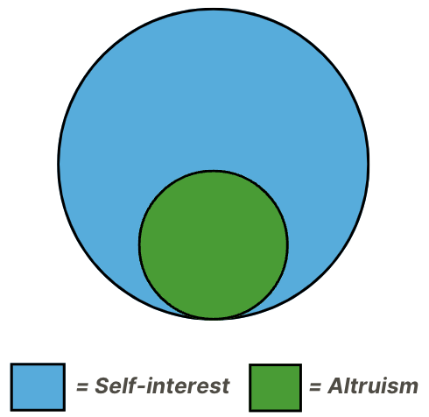

Figure : Illustration of the hierarchical structure of the Inclusion Model for Environmental Concern whereby altruistic message frames are inclusive of self-interested message frames.

The significance of this is emphasised when De Dominicis, S., Schultz, P.W. and Bonaiuto, M. (2017) undertake 3 studies all highlighting how self-enhanced message frames, whereby users’ individual self-interests are targeted, have a much greater effect on pro-environmental behaviour than using self-transcendent message frames, such as the positive impact a participant would make on the environment.

An example of this in action, is where even though societal members know, as discussed in the previous section, that transportation increases carbon emissions, damaging the environment, individuals receive an individual reward by arriving at their location faster. Similarly, if meat consumption is popular within friend groups, individuals tend to focus on the extrinsic reward of social status and keeping with social norm, prioritising this over the environmental effect.

This theory and work explains why even with access to the knowledge and tools such as carbon footprint metrics to understand and measure environmental impact, society still continues to disregard and avoid adapting to pro-environmental behaviour.

The value of De Dominicis, S., Schultz, P.W. and Bonaiuto, M.’s (2017) research is the signification that individuals may behave pro-environmentally for non-environmental reasons, such as gaining social status (Griskevicius, V., Tybur, J.M. and Van den Bergh, B. (2010)) or being healthy (Gifford, R. (2011), (2013)) and many times individuals behave pro-environmentally even without knowing they are doing so (Gifford, R. (2013)).

### **Social Identity**

Bouman, T., Steg, L. and Zawadzki, S.J. (2020) argue that the values individuals perceive their groups to endorse can critically motivate individuals to engage in pro-environmental action. In their study, Bouman, T., Steg, L. and Zawadzki, S.J. (2020) present concrete evidence where Americans with no concern for the environment begin to change their concern for the planet after groups the participants strongly identify with show environmental concern. Bouman, T., Steg, L. and Zawadzki, S.J. (2020) expand on the work of the “Social Identity” outlined by (Fielding, K.S. and Hornsey, M.J. (2016); Jans, L., Bouman, T. and Fielding, K. (2018)), whereby groups can provide standards that guide individual actions. Bouman, T., Steg, L. and Zawadzki, S.J.’s (2020) social identity argument aligns with the Inclusion Model, where self-enhancing social image is a key indicator for motivating behavioural change in individuals.

### **Lack of Responsibility - Proportion of Individual Impact**

Schwenkenbecher, A. (2014) poses in her research, “Is there an obligation to reduce one’s individual carbon footprint?” Her work tackles the societal issue of environmental responsibility and proportionality.

With increasing awareness of the proportion of individual impact being tiny compared to large corporations, society feels a lack of responsibility to tackle climate change and argues that no one individual has the capability to make a meaningful change in global emissions.

To excellently discredit this notion of individuals contributing no harm and being unable to have a significant effect, Schwenkenbecher explains in depth the power of aggregate harm, where yes individual contributions are too negligible to have a meaningful effect, but through the power of compounding, aggregated individual change leads to meaningful emission reductions. Additionally, Schwenkenbecher highlights how individual change can be influential, pushing others towards making similar change, which we have seen can be powerful in the case of social identity discussed by Bouman, T., Steg, L. and Zawadzki, S.J. (2020).

Acceptance must be made towards the fact that compounded individual acts can be harmful, and the need for individual action to be taken to break this compounding effect.

### **Conclusion**

This section has illustrated why society continues to avoid pro-environmental action even when faced with the tools and knowledge that facilitate and encourage such change. Intrinsic and extrinsic motivations play a key role in unlocking the key to achieving societal behavioural change, and without appealing to these intrinsic and extrinsic motivations, any attempts are made in vein.

## **Gamifying Carbon Footprints**

This section introduces the concept of gamification, and how it can be applied to tackle the behavioural psychology challenges outlined in the previous section, with the ultimate goal of reducing individual carbon footprints. First the theory, then the importance of selecting design features, and finally the effects of gamification as evident from existing solutions applied to climate change will be discussed.

### **Theory of Gamification**

Deterding, S. et al. (2011) define gamification as “the use of game design elements in non-game contexts”, with Sailer, M. et al. (2017) expanding on this definition, saying “to foster human motivation and performance in regard to a given activity.” The significant factor here is the purpose of gamification being to motivate behaviour change. Applying this logic to this project proposes the potential success of applying gamification principles and design to spark pro-environmental behavioural change.

At its core, gamification has three broad, categorical features: immersion, achievement and social features.

Immersive features are those such as avatars (Annetta, L.A. (2010); Peng, W. et al. (2012)), narration and personalisation (Kim, K. et al. (2015)), attempting to provide the player with a sense of freedom and control through the feeling of voluntary participation (Bormann, D. and Greitemeyer, T. (2015); Kim, K. et al. (2015); Koivisto, J. and Hamari, J. (2019), Rigby, S. and Ryan, R.M. (2011); Sailer, M. et al. (2017)), targeting the autonomy aspect of self-determination theory.

Achievement-related features are those such as badges, points, levels, leaderboards and performance graphs which ultimately target the competence aspect of self-determination theory, where users want to improve their skills or get feedback on their performance or progress (Xi, N. and Hamari, J. (2019)), valuing self-mastery and growth (Rigby, S. and Ryan, R.M. (2011)).

Social-related features are those such as teams, cooperation, competition, groups and chat, which ultimately target the relatedness aspect of self-determination theory, providing players with a sense of community and belonging stemmed from frequent communication, sharing of ideas and reciprocity (Francisco-Aparicio, A. et al. (2013)).

Each type of gamification feature fulfils a corresponding psychological user need, improving overall user experience, fulfilment and engagement with the application. By implementing a combination of immersive, achievement and/or social features, gamification can effectively achieve its goal of motivating behaviour change, when appropriate design choices are made. The theory suggests that gamification can be applied to overcome the psychological barriers outlined by self-determination theory in the previous section, ultimately resulting in meaningful behavioural change towards reducing individual carbon footprints.

Mordor Intelligence (2018) valued the global gamification market at $2.17 billion in 2017, with this figure estimated to increase to $19.39 billion by 2023. Such a valuation is a clear indication that gamification, when appropriately designed, is an effective, efficient, and widely popular method of achieving behaviour change, and is promising for achieving this project’s goal of reducing individual carbon footprints.

### **Selecting Effective Design Features**

Gamification is well known for its success in various applications by fulfilling basic psychological user needs (Sailer, M. et al. (2017)), however, one cannot assume that gamification will automatically work. Gartner, (2012) states that 80% of current gamified applications fail to meet their objectives due to poor design. This coincides with Sailer, M. et al.’s (2017) argument that “gamification is not effective per se, but specific game design elements have specific psychological effects.”

With this in mind, it is crucial to carefully plan which features to include in the design of a gamified application. Xi, N. and Hamari, J.’s (2019) research discovers that among the three broad categories of gamification features of immersion, achievement and social features, achievement features had the most significant impact on fulfilling the psychological user needs of autonomy, competence and relatedness, followed by social and then immersive features.

Each feature had its own benefits, however with immersion only targeting autonomy, and achievement features having a greater impact on autonomy, competence and relatedness than social features, achievement features were the clear winners, followed by social features as a close second.

This research provides great motivation for this project to prioritise implementing achievement features such as leaderboards, points and progress maps, before progressing on to social features such as teamwork and chatting.

### **Conclusion**

This section has introduced the theory and importance of selecting gamification design features, providing great insight into how specifically to overcome the psychological barriers to pro-environmental action outlined by the self-determination theory in section 4.

## **Existing Solutions**

This section is arguably the most important section, analysing existing solutions to gamify climate change to reduce carbon footprints. The existing solutions of “Ant Forest” and “Green Life” will be analysed, 2 solutions with contrasting levels of success.

### **Ant Forest**

Ant Forest is a Chinese based application, which pioneered the use of gamification for public environmental protection. As shown in figure 2, users on the platform can earn "green energy" to cultivate a virtual tree by online and offline low-carbon behaviours. When the virtual tree grows, a real tree will be planted by the public welfare partner of Ant Financial Services Group. The Ant Forest has now developed multiple forms of gamified interactions, such as team up or race with friends (Cao, Y. et al. (2022)).

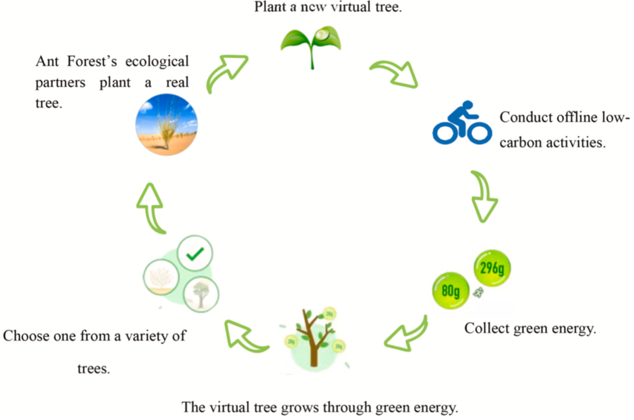

Figure : Workflow of Ant Forest application to promote and gamify pro-environmental behaviour (Cao, 2022).

The success of Ant Forest is indicative of its user base reaching 500 million users as of 2019, all participating in reduced carbon actions. The cooperative and competitive features in Ant Forest have resulted in more than 20 million tons of “green energy” (It takes at least 17 kg of "green energy" to plant one tree). To put this into perspective, the carbon emissions reduction of this “green energy” is equivalent to saving 29.4 billion kwh of electricity, which is equivalent to one full day of China’s electricity consumption (Cao, Y. et al. (2022)).

This impressive reduction is proof that individual environmental action, when aggregated, can have significant benefits, as outlined previously by Schwenkenbecher, A. (2014) in her paper on the proportion of individual impact.

Not only have emissions drastically reduced, but Ant Forest is evidence that individual environmental change, can influence others to do the same, as seen by companies agreeing to work with Ant Forest to incentivise green consumption behaviour, again previously proposed by Schwenkenbecher, A. (2014).

As such, Ant Forest is hard evidence that applying gamification to climate change can reduce carbon footprint scores. With such success, Ant Forest is a key motivation for the design and rationale of this project.

### **Green Life**

“Green life” is an application that encourages waste separation and recycling by offering free trash bags or other cash rewards. Having an underwhelming user base of 700,000 users in total so far, with a concerning application store rating of only 2.3 out of 5, “Green Life” is a good example of how solely providing financial incentives is inadequate to achieve behavioural change amongst a wide customer base. Green Life is the perfect illustration of the danger of assuming any form of gamification will result in effective behavioural change, and that, as previously mentioned by (Gartner, 2012), 80% of current gamified applications were estimated to fail to meet their objectives due to poor design. With this example in mind, this project will focus on the most effective combination of gamification features needed to achieve the desired environmental behavioural change.

## **Conclusion**

This literature review has analysed the area of a carbon footprint, outlining the need for an adapted carbon footprint metric, targeted at the most contributary actions towards carbon emissions. After identifying the problem of an environmental knowledge-action gap, the central motivation for this project, the self-determination theory, the Inclusion Model for Environmental Concern, social identity and lack of responsibility put into perspective why such infrequent action is taken. By connecting the ability of gamification to tackle these psychological barriers to pro-environmental behaviour change, and analysing this in practice through existing solutions of Ant Forest and Green Life, motivations and direction will be taken forward throughout this report, to aid in the design of the mobile application to be built in this project.

# **Design**

This chapter discusses the design for the social mobile application created in this project. Firstly, insights from the literature review discussed in the previous chapter will be presented, then a requirements analysis from the field of Human Computer Interaction (HCI) is presented with insights from this analysis. Following this, both low and high-fidelity prototypes will be presented before establishing the final requirements.

## **Literature Review Insights**

The literature review discussed in chapter two of this report examined the areas of carbon footprints and carbon footprint calculators, behavioural psychology and effective gamification design. Based on the literature review, the prioritised value-adding features which should be implemented to address the psychological user needs of autonomy, competence and relatedness, based off of the self-determination theory, are achievement and social features, competition and cooperation, a quick and easy footprint calculation and a way to educate users. As discussed in the literature review there are a variety of ways to include these features, and the specific ways implemented in this social mobile application are points, a leaderboard and an individual progress chart for achievement features, team and individual leaderboards for social features, to focus on meat consumption and transport for a quick footprint calculation, individual leaderboard for competition, a team leaderboard for cooperation and finally to view the emissions from various activities to educate users. These 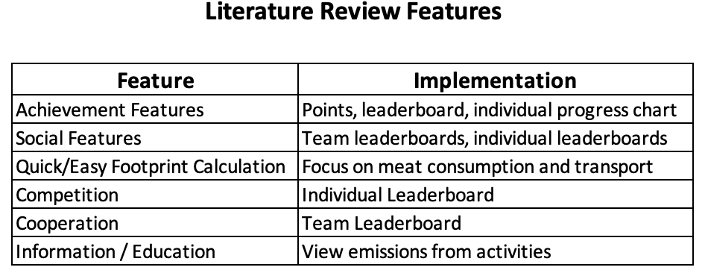insights are illustrated in figure 3 below.

Figure : Table of the recommended features from the literature review in the 1st column, with how the feature can be implemented in the application in the 2nd column.

As discussed in the literature review and illustrated in figure 3 above, competition, cooperation, information, achievement features and social features are highly effective functional requirements for implementing mobile applications targeted at motivating pro-environmental behavioural change.

In addition, a quick, reduced user effort footprint calculator is needed, focusing on meat consumption and transport. This is because meat consumption, transport and energy usage are the three most contributary components of an individual’s carbon footprint, but energy usage requires pre-prepared knowledge of utility bills and information which is more difficult for users to collect, as well as not having control of these emissions such as how a home is powered when renting or living with parents, as previously outlined in the literature review. Thus, meat consumption and transport are the emission factors this application focuses on collecting from user input.

It is important to note that the literature review also referenced other features which could add value such as immersive gamification features (avatars, narration), but with the limited time constraint of this project and adhering to agile best practices, the features which add the most value are of the highest priority.

## **Human-Computer Interaction Analysis**

This section implements the frameworks used in the field of Human Factors (HF), or Human Computer Interaction (HCI), namely scenarios and hierarchical task analysis, to develop further insight into what users may feel, experience and what they are trying to achieve by using the gamified mobile application in this project. By implementing the scenario and hierarchical task analysis frameworks, improvements can be made to the design of the application to provide a more seamless experience for the users.

### **Scenarios**

This section provides a user scenario associated with the mobile application to be built for this project. The scenario illustrated in this section is that of an unmotivated environmentalist. The purpose of this section is to gain insight into how the users feel, what they experience and what they are trying to achieve when using the mobile application, taking into account their personal characteristics and diverse backgrounds.

#### **Unmotivated Environmentalist**

Dave is a student at Trinity College Dublin, where he studies Environmental Science. Dave has always been fascinated by science and often spends his time outdoors enjoying nature and watching documentaries about the environment. Dave is environmentally concerned but lacks motivation to take meaningful action to reduce his carbon footprint because there is nothing holding him personally accountable for his environmental actions and it is too easy to avoid change. Any consequences for his lack of action he feels is too distant and does not affect him directly, feeling limited relatedness. Dave wishes there was an easy way to increase his motivation to reduce his individual carbon footprint.

While researching academic papers for an assignment, Dave comes across a gamified social mobile application where students compete individually and in teams through their carbon footprints. Dave has experience using carbon footprint calculators and has frequently found them to be too time-consuming, requiring too much effort and ultimately frustrating and de-motivating him. If the calculation of his footprint does not require much effort, Dave would like to use the application to compete against his friends, hopeful that this application will help him feel accountable. Ultimately, Dave sees this application as a great opportunity to help him achieve his goal of increasing his motivation for reducing his individual carbon footprint.

After signing in to the application with his credentials, Dave observes the screen displayed to him. He notices the “+” button and his intuition leads him to click it, confident this button facilitates logging an emission. Next, Dave sees the option to select either a transport emission or a food emission. Dave selects a transport emission. Dave sees a list of fields he needs to fill in and immediately feels concerned because of his experience using time-consuming carbon footprint calculators in the past. Dave is prompted to select what size car he uses, which he has no idea. Dave notices the option to select “average”, and selects this, feeling grateful the application catered for his lack of knowledge about his car’s engine size.

Next, Dave selects diesel as his fuel type. Since he drove by himself to work Dave selects 1 for the number of passengers. Since Dave has driven to work every day he knows the commute distance is 4.8km. By accident, Dave enters 48 and selects kilometres. To log his commute, Dave selects “save”. After selecting “save”, Dave is shown the information he has entered and is asked to confirm the details are accurate. Dave glances through the details and notices he entered 48 instead of 4.8km and quickly fixes this mistake, before clicking confirm. Dave is grateful the application prompted him to review his entry, preventing him from logging an incorrect distance, and appreciates how easy it was to change the distance entered.

After arriving home from work, Dave opens the application to log his commute home. To his delight, Dave sees the new entry has his previous commute entry already filled in. Dave simply clicks save, confirming his new log and takes great satisfaction in not having to refill in all the details all over again.

At the end of the day, Dave views his position in the individual leaderboard by selecting this tab in the navigation bar and sees he is ranked third out of fifth amongst his friends. Dave appreciates the speed at which he can access the leaderboard through the navigation bar. In the team leaderboard his team is coming 4th and he notices this is because his score has dragged them down. Dave feels the urge to improve his score in the future so he does not let his team down.

After logging his emissions through the application and competing with his friends through his carbon footprint score, Dave notices an overall reduction in his carbon footprint over time and takes great comfort in the environmental change the application has brought about amongst him and his friends. Dave’s environmental concerns begin to ease and he is relieved to finally feel motivated to take meaningful action to reduce his carbon footprint. Feeling personally accountable to help his team win, Dave finds it difficult to avoid changing his damaging environmental actions and that the consequences for his lack of action is reflected on a day to day basis. By competing against his friends, Dave’s motivation to improve his environmental behaviour improves greatly, giving him a great appreciation for how convenient and helpful the application is.

### **Hierarchical Task Analysis**

Following on from the scenario discussed in the previous section, this section provides the hierarchical task analysis for logging emissions, which was a focal task in the previous scenario, offering insights into the most frequent, complex, and error prone tasks.

#### **Log Emission**

0. Log Emission

1. Sign in

1.1. Enter email

1.2. Enter password

1.3. Select sign in

2. Add Emission

2.1. Select add emission

2.2. Select emission type

2.3. Add transport emission

2.3.1. Select mode of transport

2.3.2. Select car size

2.3.3. Select fuel type

2.3.4. Enter number of passengers

2.3.5. Enter distance

2.3.6. Select unit of distance

2.4. Add food emission

2.4.1. Select food type

2.4.2. Enter portion size

2.4.3 Select unit of measurement

2.5. Select save

2.6. Select cancel

3. Confirm action

Plan 0: Do 1, then 2, then 3.

Plan 1: Do 1.1, then 1.2, then 1.3.

Plan 2: Do 2.1 then 2.2. If 2.2 equals transport, do 2.3., else if 2.2 equals food, do 2.4. Do 2.5 or 2.6.

Plan 2.3: Do 2.3.1. If 2.3.1. equals dart, Luas, bus or train, then skip to 2.3.5. Do 2.3.5 and 2.3.6 in any order. If 2.3.1 equals car, do 2.3.2., 2.3.3., 2.3.4., 2.3.5., and 2.3.6., in any order.

Plan 2.4: Do 2.4.1, then do 2.4.2. and 2.4.3 in any order.

##### **Log Emission Analysis**

With logging an emission, the most frequent tasks involve filling out all the details time and time again. This may prove to be painful for users and time consuming if they have the exact same commute to work every day, or they eat the same food for certain meals. A solution to solve this pain point of users could be the option to save or copy a previous entry, with the ability to edit the new copied entry.

Complex tasks are those which either take a long time, or can be confusing to complete. Complex tasks for logging an emission involve knowing the car size, knowing the portion size for eating food, converting the portion size from one unit to another and converting distance travelled from one unit to another. Knowing the distance travelled itself is not considered complex because users can easily use google maps.

Solutions to the above complex tasks involve providing average or recommended values for fields which users may not know an accurate answer for such as engine size and portion sizes for food and to provide different units of measurement for portion size and distance travelled because users may be more familiar with kilograms instead of pounds, or miles instead of kilometres and some food packets provide different units of measurement.

Serious errors in logging emissions involve making mistakes such as forgetting to add a decimal point for distance travelled or portion size of food. Additionally, if users cannot remember if they have already logged an emission leading to duplicate logs, or no log at all because they think they have already recorded this activity.

Solutions to these serious errors outlined above involve providing a summary of the emission entry asking user to confirm, cancel or edit the entry, displaying a history of logs for the current day to avoid duplicates or forgetting to enter an activity and providing the ability to edit or delete logs once confirmed if duplicates or incorrect logs are made.

### **Scenarios and Hierarchical Task Analysis Insights**

The scenario and hierarchical task analysis discussed in sections 2.1. and 2.2. provide great insight into what users may experience, reflecting good or bad design decisions. By taking into account diverse user abilities and backgrounds, as well as the most frequent, complex and error prone tasks of using the application, overall design of the application can be drastically improved.

By analysing the scenarios and hierarchical task analyses, value-adding features to address frequent, complex and error prone tasks of using the mobile application can be established. The most value-adding features from the insights analysing the scenario and hierarchical task analysis in the previous sections are illustrated in figure 4 below.

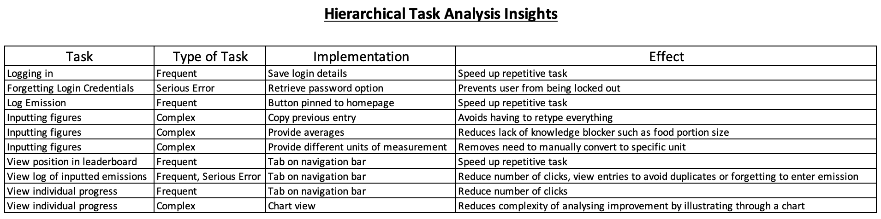

Figure : Insights gathered from Hierarchical Task Analysis which outlines how to improve design through adding value-adding features to improve user experience when using the mobile application to motivate pro-environmental behavioural change.

## **Prototyping**

This section focuses on prototyping, further applying the knowledge from the field of Human Factors and Human Computer Interaction (HCI). In this section, low-fidelity (hand drawn) and high fidelity prototypes were created to visualise the users’ workflow, simulating their experience with using the application.

### **Low Fidelity (Hand Drawn) Prototypes**

The first stage of prototyping for this mobile application began with low-fidelity prototypes in the form of hand drawn prototypes. Hand-drawn prototypes were first created since they are very quick to create, effectively aid in visualising user flow and avoid the designer experiencing sunk-cost fallacy, where the designer is reluctant to abandon the prototypes because they have spent a lot of time working on the prototypes, even though they know abandonment would be more beneficial” (Ronayne, D., Sgroi, D. and Tuckwell, A. (2021)).

Figures 5-12 below illustrate the original hand-drawn prototypes for the application.

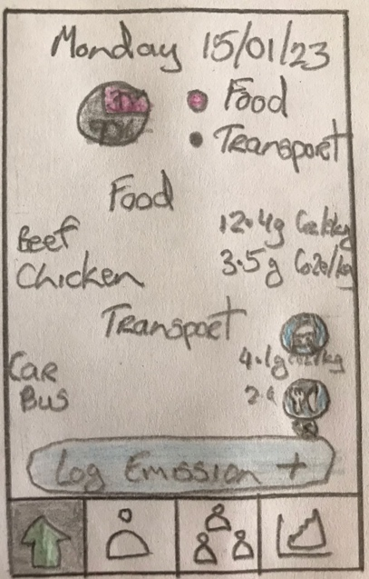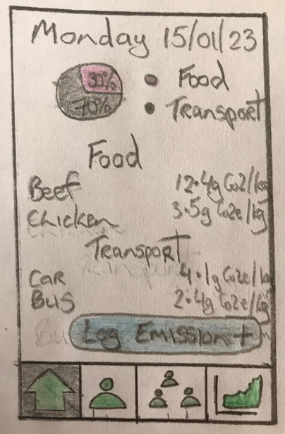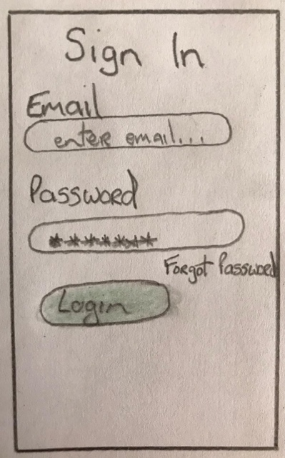

Figure : Login screen.

Figure : Home screen.

Figure : Home screen expanded.

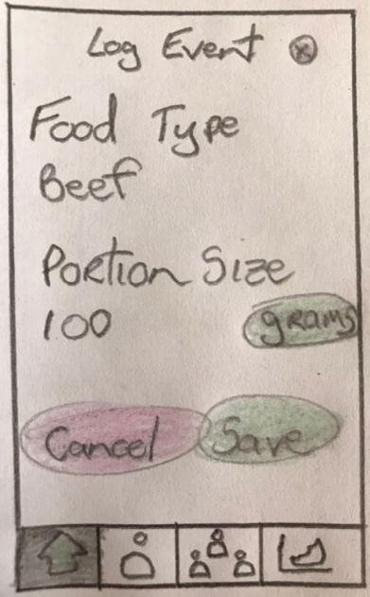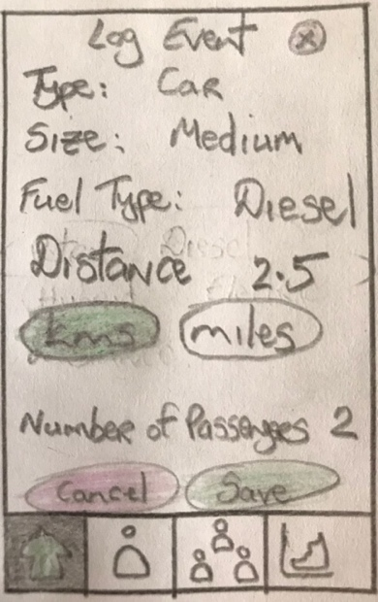

Figure : Log transport emission screen.

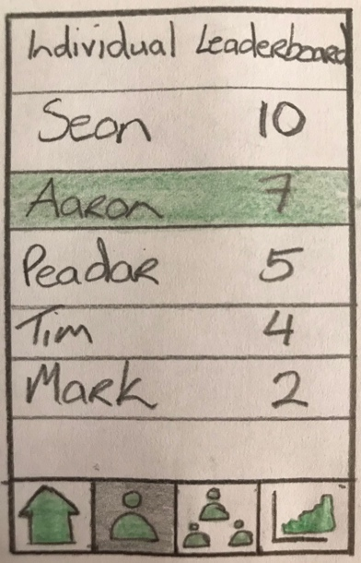

Figure : Log food emission screen.

Figure : Individual leaderboard screen.

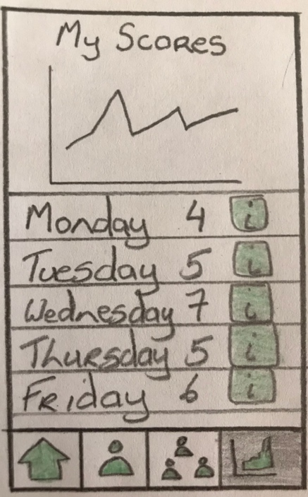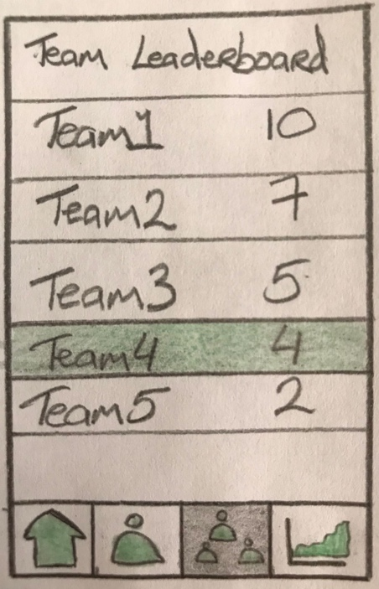

Figure : Team leaderboard screen.

Figure : My scores screen.

### **High Fidelity Prototypes**

After analysing and iterating through different versions of low-fidelity prototypes, high-fidelity prototypes were then created using the online software tool Figma. The high-fidelity prototypes provide a cleaner, crisper, more realistic user experience to further gauge feedback from users’ experience, frustrations and enjoyment with using the application.

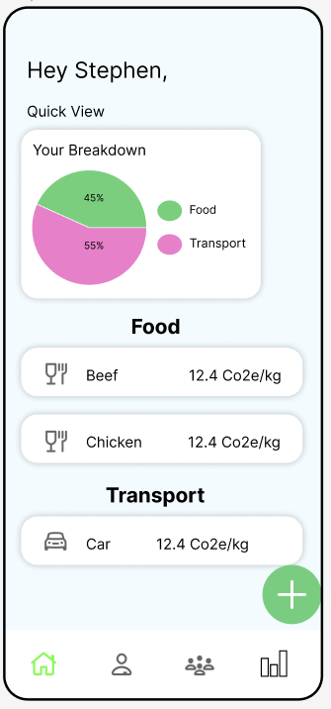 Figures 13 – 19 below illustrate the high-fidelity prototypes for the application.

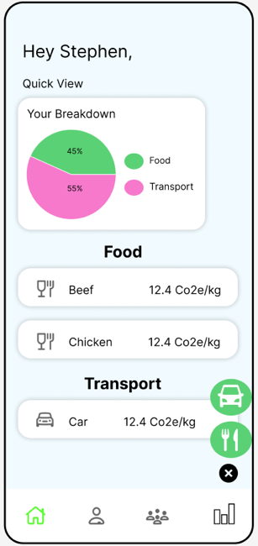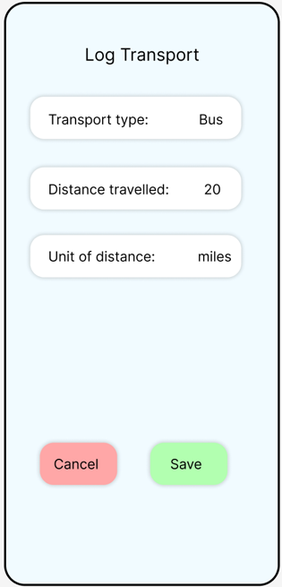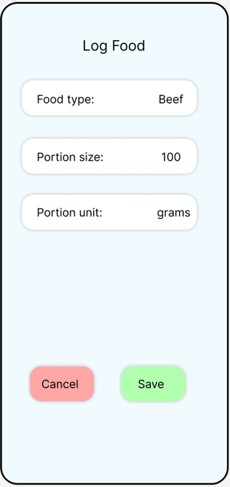

Figure : Home screen.

Figure : Home screen expanded.

Figure : Log transport emission.

Figure : Log food emission.

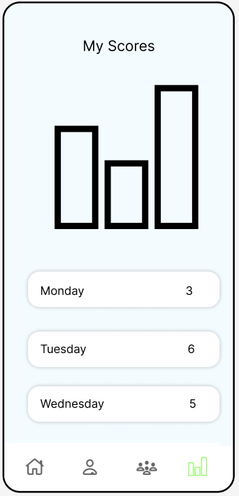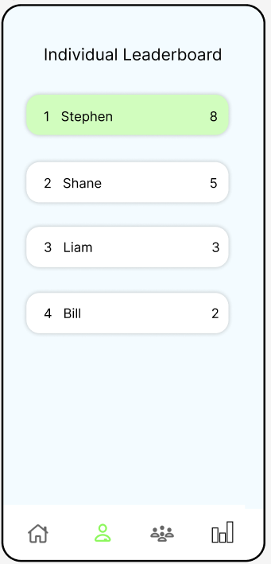

Figure : Individual leaderboard screen.

Figure : Team leaderboard screen.

Figure : My scores screen.

### **Conclusion**

This section has explained how in addition to the literature review insights, scenarios and hierarchical task analyses drive the design decisions rationale. After analysing the prioritised list of value-adding features from the literature review and from the scenarios and hierarchical task analyses, there is heavy overlap across these prioritised lists. Various other features could be added to the mobile application at a later stage, but to deliver the most value in the given time constraints of this project, the features outlined in the previous sections will be the focus for implementation.

### **Final Requirements**

Taking the collective insights provided by the literature review in chapter 2 and the human computer interaction analysis in the previous section, the final requirements are established below, categorised into functional and non-functional requirements.

**Functional Requirements**

* Login
* Log food emission
* Log transport emission
* View history of today’s logs with carbon footprint contribution
* Compete in individual leaderboard
* Cooperate and compete in team leaderboard
* View individual progress chart of scores over time

**Non-functional Requirements**

* Cross-functional application
* Easy to use application
* Frequent tasks are performed quickly
* Complex tasks’ complexity is broken down
* Limited likelihood of user errors

## **Conclusion**

By reviewing insights from the literature review, analysing user experience through a scenario and hierarchical task analysis of logging an emission, and by iteratively creating the hand-drawn prototypes and then progressing to high fidelity prototypes to visualise user flow, the design for the gamified mobile application to be implemented in this project has been established, alongside the functional and non-functional requirements.

# **Implementation**

Having outlined in the previous chapter how the application should be designed, this chapter focuses on how the author implemented this design, discussing the tools used, the architecture of the application, and the front end and the back end of the application.

## **Tools Used**

React Native was the development language of choice for the application. Additional tools such as XCode and Android Studio, the Integrated Development Environments (IDEs) for iOS and Android respectively, were needed to create emulators to test the application on these platforms. Additionally, GitHub was the tool used for version control to ensure any progress was not lost and that had the author ran into any unforeseen circumstances where there was some issue with the application, he could simply continue from a previously working version of the code.

**VSCode**

VSCode was used as the integrated development environment (IDE) of choice by the author due to industry popularity with this IDE, a vast collection of available extensions such as prettier used for code formatting, and because of the author’s familiarity and experience with this IDE.

**XCode**

XCode is the IDE for developing iOS applications. XCode was required to run and test the application on iOS software. By utilising XCode, the author was able to test the application across various different iPhone simulators, ensuring reliability regardless of the specific version of iOS.

**Android Studio**

Similarly to XCode, Android Studio is the IDE for developing Android applications. Android Studio facilitated running and testing the software on an android phone, ensuring reliability for Android users of the application.

**GitHub**

GitHub was used for version control. The decision was made to use GitHub to adhere to software engineering best practices. Alternative version control systems such as BitBucket and TortoiseSVN were considered, however, due to the author’s existing familiarity, GitHub was ultimately decided. A screenshot of the author’s private GitHub repository is provided below in figure 20.



Figure : Screenshot of the author’s private GitHub repository containing source code and documentation for the application.

## **Technologies Used**

**React Native**

React Native was the development language of choice. The author chose React Native over Swift and Java/Kotlin because React Native is cross-platform whereas Swift and Java/Kotlin are native, only working on either iOS or Android respectively. Flutter is an alternative cross-platform development language which was considered, but ultimately the author favoured implementing the application through React Native due to extensive online documentation and transferable skills whereby React Native is very similar to React, which is a development language used for building websites.

**Firebase Cloud Firestore**

Firebase Cloud Firestore was chosen to facilitate database functionality, saving user progress, scores and data as they used the application. Firestore Realtime Database was also considered for implementation, however, having analysed the specific use case for this application and the type of and frequency of the kind of database calls which would be used for this application, the more flexible noSQL Firebase Cloud Firestore schema was a far greater match than the strict schema of the SQL Firestore Realtime Database. Further discussion and illustration to this point will be justified through the emission logs screenshots in section 4.6 of this chapter on the database.

**Firebase Auth**

To facilitate and store user login credentials, Firebase Auth was used. This technology caters for unsuccessful login attempts, providing the user with an informative alert as why their login attempt was unsuccessful. Upon successful login, the user’s data is retrieved from the Firebase Cloud Firestore database and returned to the React Native front-end.

## **Architecture**

The technologies used to implement this application were React Native for development and the front-end application, making use of various libraries such as those to illustrate pie and line charts, and Firebase Cloud Firestore for the back-end database, with Firebase Auth handling user authentication when logging in. These technologies are illustrated in figure 21 below, where React Native reads and writes data to the database, attempts logging in through Firebase Auth, and the database and Firebase Auth in return send back data to React Native.

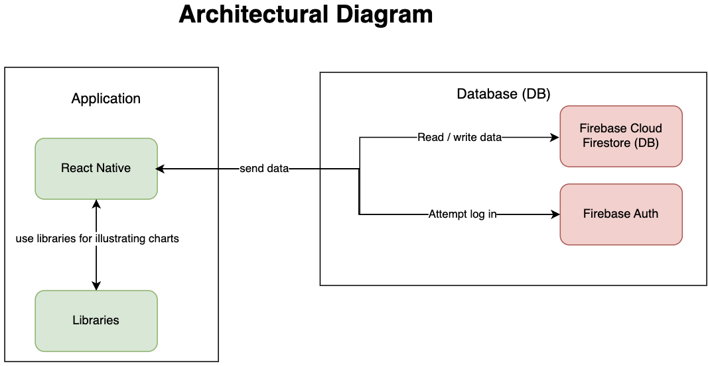

Figure : Architectural Diagram illustrating the different technologies used to build the application and how they communicate.

## **User Flow Diagram**

Various user flows, or sequence of interactions within the application exist for users. Figure 22 below illustrates the different avenues users may take, presenting the conditional effects of successful and unsuccessful attempts at tasks. After logging in, the core tasks users perform are to view today’s logs, add a log, view individual and team leaderboards and to view individual history of scores. The user flow presented in figure 22 highlights how adding a log is the most complex task, where food or emission log selection determines the next steps of what details are required. There is no particular end to this user flow as the user can navigate from one task to another through the navigation bar.

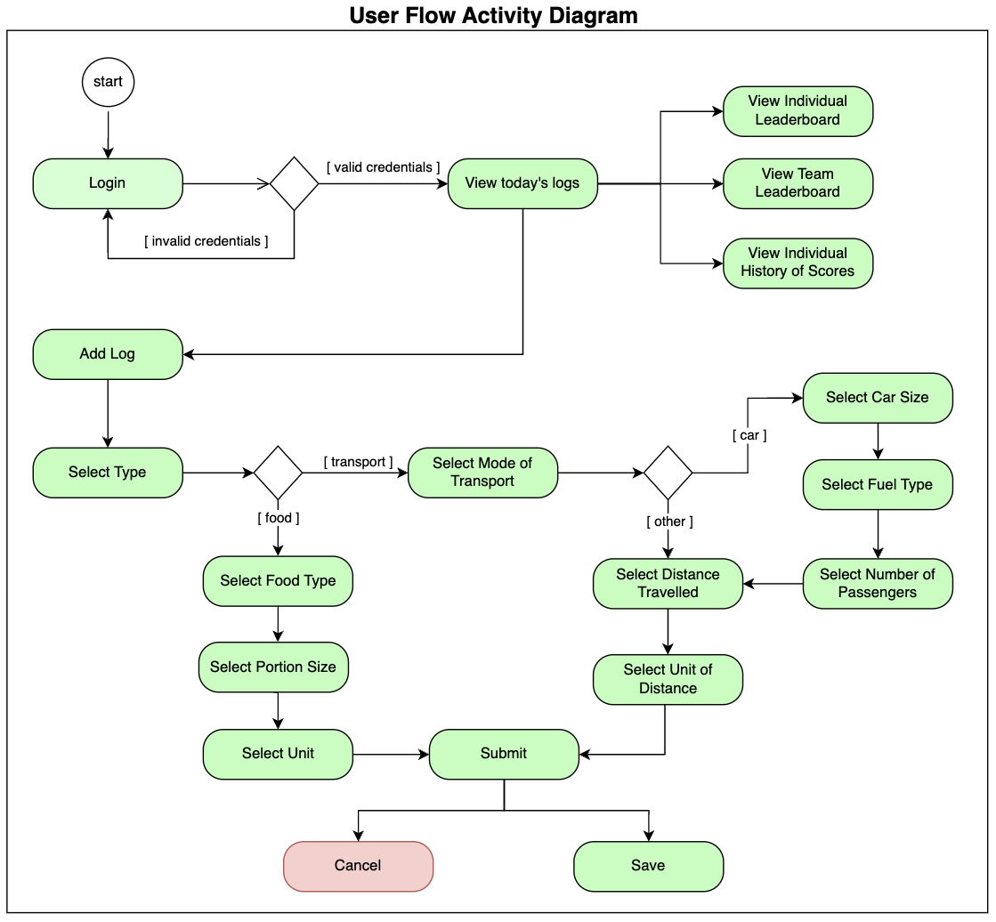

Figure : User flow represented by activity diagram.

## **Final User Interface (Front End)**

Having established important design considerations in chapter 3 of this report, the below screenshots illustrate the final user interfaces for the application with rationale as to why they were designed this way.

**Login**

The login page is very basic, providing only the information needed for users to sign in, preventing unnecessary clutter, contributing to a clean and tidy display. Although the required inputs are arguably considered universally understood in this day and age, placeholder inputs are provided to aid the user in the event of any confusion, as illustrated by figure 23 below.

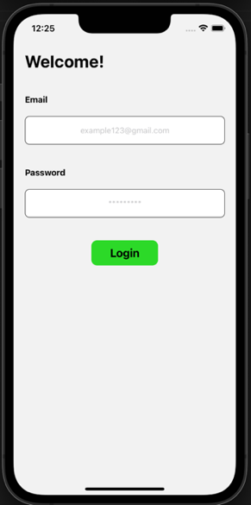

Figure : Login screen.

**Homepage**

The homepage provides users the ability to review emission logs, an important feature highlighted in chapter 2 on design, to limit the likelihood of serious errors such as forgetting to log an emission or having duplicate logs. Additionally, insights from the literature review emphasised how the best rated carbon footprint calculators provide a breakdown for users of their emissions, offering education and removing ambiguity. Figure 24 illustrates the home screen.

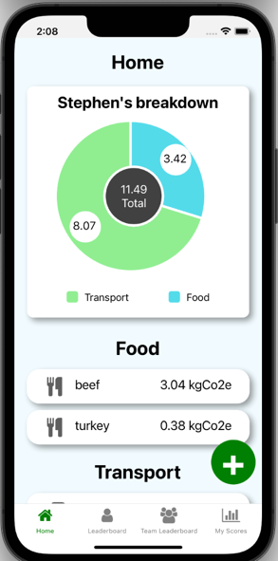

Figure : Homepage screen.

Additionally, grouping similar items together can reduce the complexity for users in their quest to check for duplicate or missing logs as illustrated by figure 25.

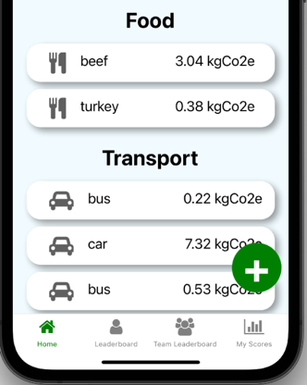

Figure : Home page groups similar logs under food and transport headings accordingly.

**Log Emission Button**

The log emission button, illustrated in figure 26, has been implemented to remain visible on screen as the user moves around the homepage. The design chapter highlighted the importance of speeding up frequent tasks, and being able to click the log emission button from anywhere on the home screen achieves this need to speed up this frequent task of logging emissions.



Figure : Log emission button on home page.

**Log Food Emission**

The log food screen presented in figure 27 is very minimal, where users input the food type, portion size and unit of measurement for the food log, before saving this log. Clicking save will lead to the confirmation alert illustrated in figure 33 further on in this report.

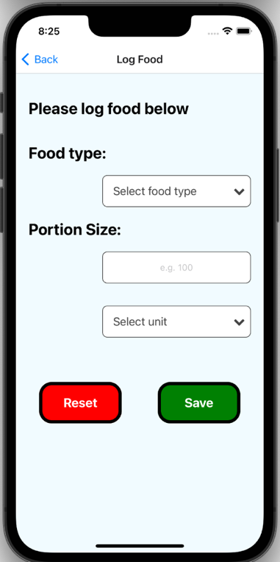

Figure : Log food screen.

**Log Transport Emission**

Likewise with the log food screen, the log transport screen presented in figure 28 is minimal, where users input the mode of transport, distance travelled and unit of distance travelled. Additional fields such as engine size are required if the mode of transport selected is a car. Again, clicking save will lead to the confirmation alert illustrated below.

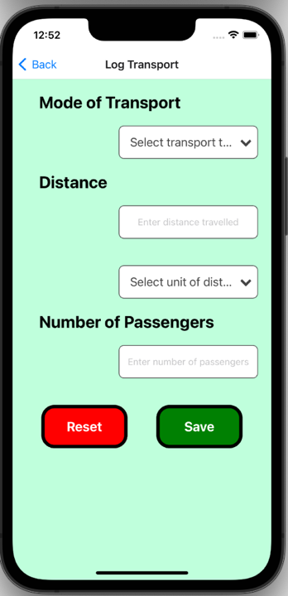

Figure : Log transport screen.

**View Individual Leaderboard**

Simple, clear, tidy headings of “Yesterday’s Score” and “Individual Leaderboard” are displayed on screen to remove any ambiguity for the user. If they get distracted from their phone and then come back to this screen, it is clear which leaderboard they are looking at.

The logged in user’s score is highlighted in green to speed up and reduce the complexity for the user of locating their position in the leaderboard, as illustrated by figure 29 below.

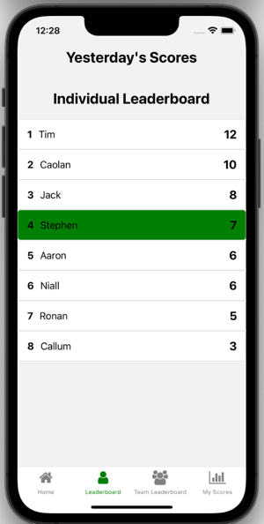

Figure : Individual Leaderboard screen.

**View Team Leaderboard**

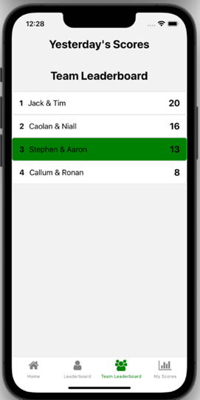Just like the individual leaderboard, the team leaderboard, illustrated in figure 30, contains clear headings and highlights the logged in user’s team’s position in the leaderboard, increasing speed and reducing complexity for the user when locating their position. If a user is constantly winning or losing in the individual leaderboard, their teammate’s (only one teammate) score may alter the balance, providing a more competitive landscape to compete in.

Figure : Team leaderboard screen.

**View Individual History of Scores**

Represented in figure 31, this screen sustains motivation, whereby users who are either winning or losing all of the time, lacking motivation or a challenge against their peers, can find competition against themselves, targeting the competence aspect of self-determination theory where they can strive to master their performance.

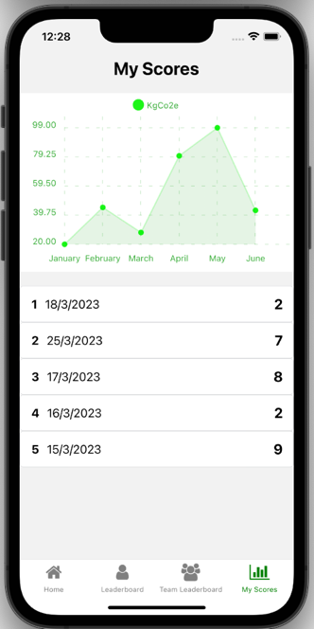

Figure : My Scores screen.

**Navigation Bar to Speed Up Frequent Tasks**

The navigation bar, in figure 32, speeds up the frequent tasks of viewing your emission logs, individual and team leaderboards and individual history of scores where these tasks are only 1 click away for users. Additionally, similarly to the leaderboard, the active tab in the navigation bar changes colour to green to reduce cognitive load on the user as to what screen they are on.



Figure : Navigation bar.

**Confirmation Button to Reduce Likelihood of Errors**

Analysing the hierarchical task analysis of a user logging their emissions in chapter 2 on design revealed the importance of limiting the likelihood of errors such as entering incorrect emission log data, leading to the implementation of this confirmation button illustrated in figure 33.

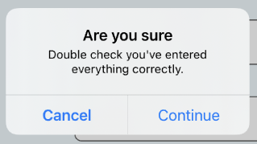

Figure : Confirmation button.

**Reducing Complexity Through Variety of Units of Measurement**

As discussed when analysing the scenario and hierarchical task analysis of a user entering emission logs in the design chapter, complex tasks involved converting one unit of measurement into another and also selecting car size. As such, to reduce these complexities, a selection of different units of measurement are provided, catering for users who are used to different units of measurement, and the average car size is provided, catered for users who do not know the size of their car, thus reducing complexity and cognitive load placed on users. These features are illustrated in figures 34, 35 and 36 respectively.

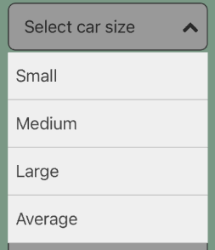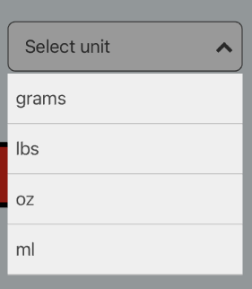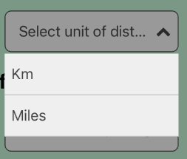

Figure : Variety of units of distance.

Figure : Variety of units of portion size.

Figure : Average car size provided.

## **Database (Back End)**

The database used for implementing this gamified, social mobile application was Firebase Cloud Firestore, a noSQL schema which consists of collections and documents. As discussed in section 4.2. of this chapter, this database was chosen for the increased flexibility offered by the schema.

The design of the implemented database was motivated by industry standard database best practices, of avoiding redundancy, and following the noSQL golden rule of making collections large and documents small. The content below contains screenshots and explanations to the different aspects of how the database was implemented.

**Storing Authenticated User Accounts on Firebase**

Each authenticated user has an email and password associated with their account to login, as well as having a unique user id or “User UID” to identify and refer to the associated user in collections and documents. These authenticated accounts have been created by the author to facilitate the creation of teams, with one account being provided for each participant when evaluating this application. Figure 37 illustrates these accounts in Firebase.

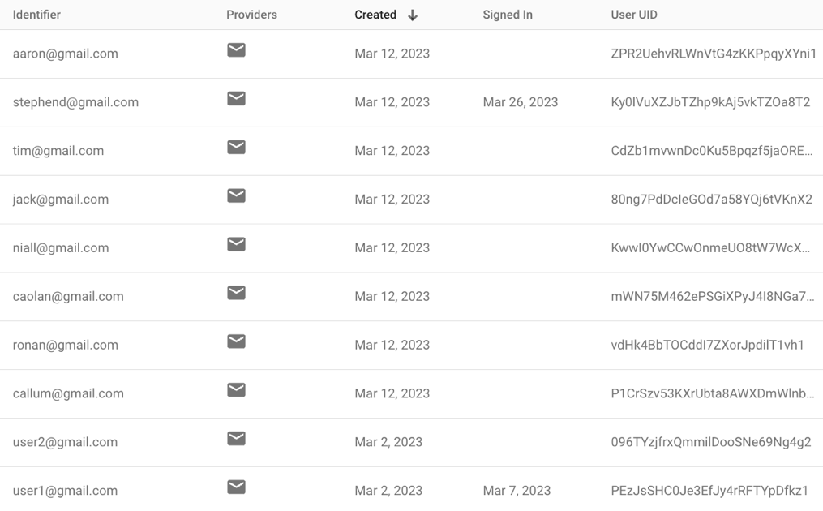

Figure : Authenticated users in Firebase.

If the entered credentials of an email and password do not match any authenticated user accounts, the user is alerted of invalid login credentials and will not proceed to the homepage. Upon supplying valid credentials, users are navigated to the homepage, and the unique ID to identify this specific user is carried forward as displayed in figure 38.

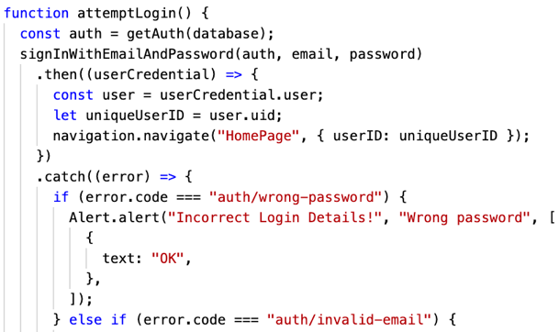

Figure : Code to attempt a login.

**Collections**

The collections implemented in the database for this application were for the emission logs, scores, teams and users, as highlighted by figure 39. The scores collection could arguably be redundant, since these scores can be calculated from the emission log documents, however, the time taken to recalculate every single score proved too costly, justifying including scores as a separate collection. Further rationale is provided in the score document section further on in this report. Contrastingly, the author considered having a leaderboard collection which contained the associated scores to be displayed on this leaderboard, however, this was decided to be redundant because the scores are already stored in the database, and the time taken to retrieve them for display in the leaderboard is negligible compared to the time of calculating every score from all emission logs.

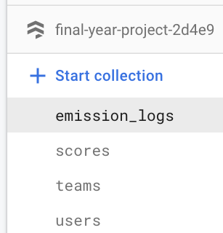

Figure : Database collections stored in Firebase.

**User Document**

Note, the user documents do not contain a “uniqueID” field because this value is stored as the unique ID for the document itself, which is connected to the unique user ID assigned to each authenticated user as per the screenshot above. For example, in figure 40, Jack’s uniqueID is 80ng7PdDcIeGOd7a58YQj6tVKnX2.

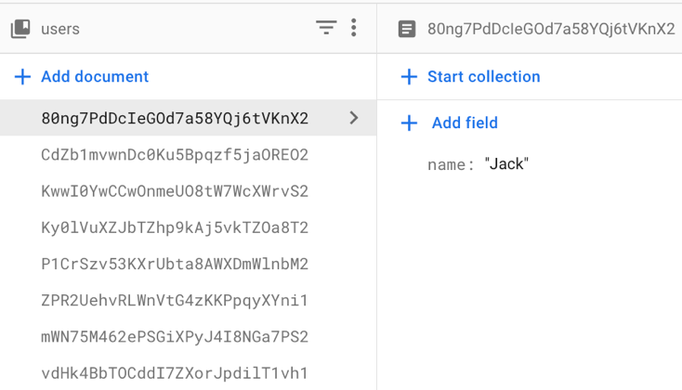

Figure : Example user document.

**Team Document**

The decision was made by the author to include the associated user IDs for the team members as an array inside of the team document because the team size is fixed to a size of 2. As such, the size of this array, and therefore the size of each team document, will not grow infinitely, exceeding the 2MB capacity limit for Firebase documents. Participants using this application were put in to teams pre-determined and created by the author. Creating and joining teams was decided to be an area for future work as the priority was merely to place participants in teams. Figure 41 presents an example team document.

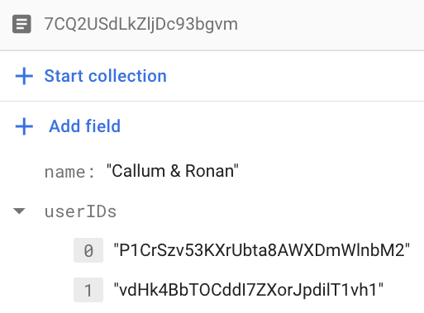

Figure : Example team document.

**Emission Logs**

The 2 types of emission logs for the gamified social mobile application are food and transport logs. The example food and transport documents illustrated in figures 42 and 43 below highlight the benefit of using the noSQL database schema of Cloud Firestore where documents in the same collection can have different fields, versus using the relational database management system style of Firebase Realtime Database where all documents in a collection must follow a strict criteria of having the same fields. As screenshots x and y below illustrate, a food emission log document has fields such as “portionSize” and “portionUnit”, whereas a transport emission log document has fields such as “distanceTravelled” and “unitOfDistance”. Had a relational database such as Firebase Realtime Database been used, separate collections for food and transport logs would need to be created, adding unnecessary complexity to the database design.

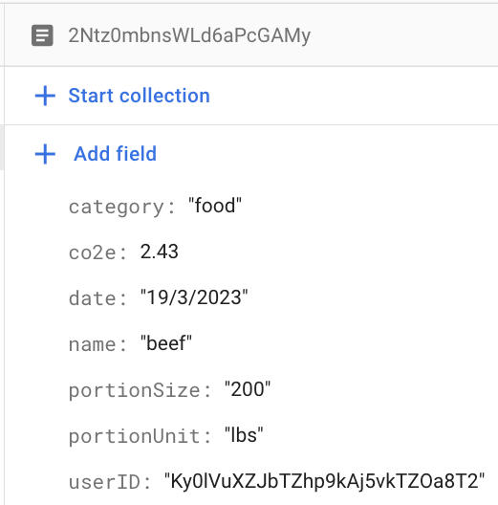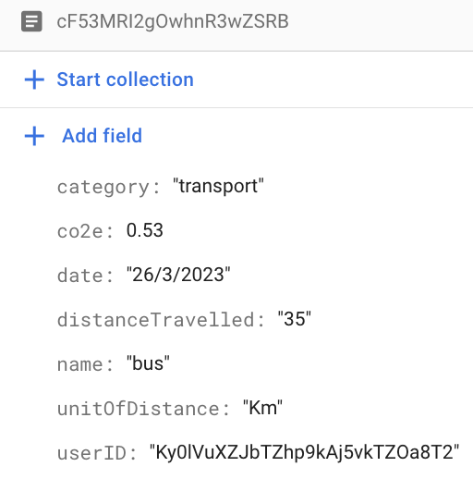

Figure : Example food emission log document.

Figure : Example transport log document.

**Adding Logs to Database**

The addLogToDatabase functions displayed in figure 44 and 45 are triggered when the user confirms their log details after clicking the save button on either the log transport or log screen pages.

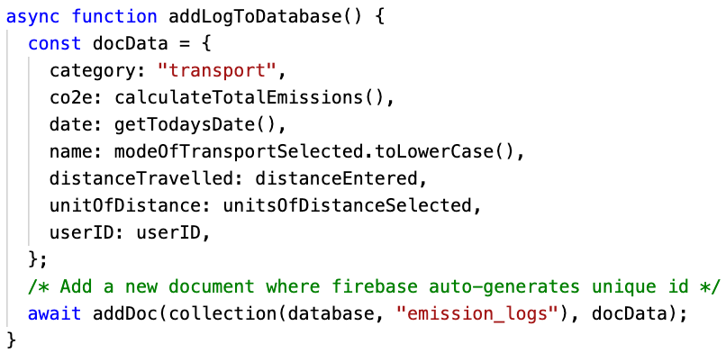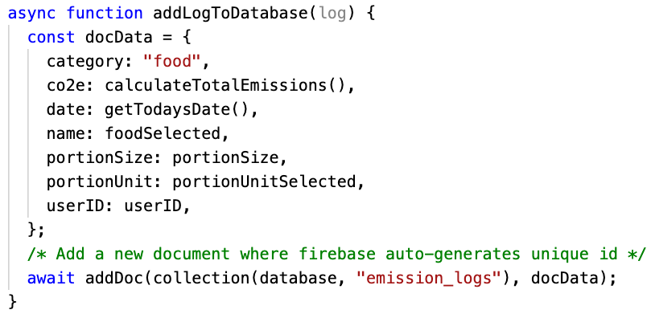

Figure : Code to add a food log.

Figure : Code to add a transport log.

**Calculating Emission Log’s Carbon Footprint**

To calculate a transport log’s carbon footprint, or carbon dioxide equivalent (co2e), the distance entered is converted from miles into kilometres if necessary, before being multiplied by the co2e output per kilometre of the mode of transport selected, which is retrieved from the transport data map illustrated in figure 47. The code for this logic is illustrated below in figures 46 and 47. A similar process is carried out for a food log’s co2e. The sources for co2e emissions displayed below in figure 47 are from the UK government and the Irish Times (Department for Energy Security and Net Zero (2020), Comyn, P. (2009)).

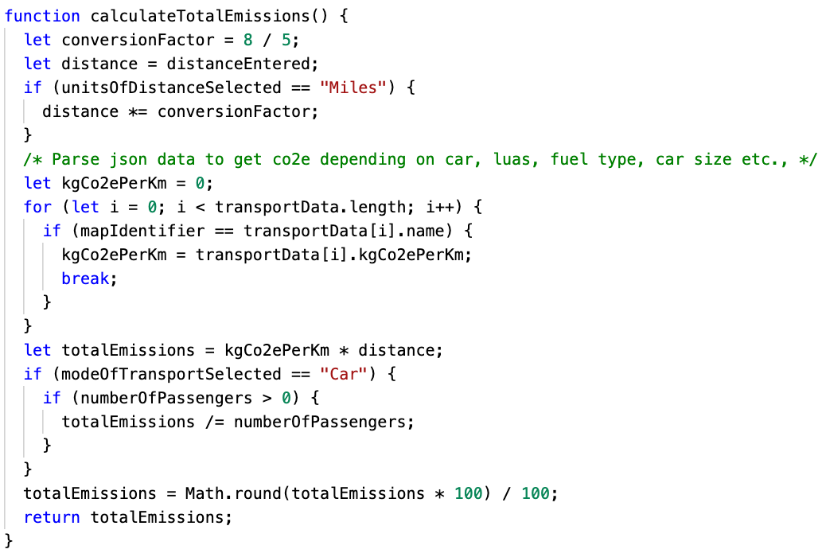

Figure : Code to calculate co2e emissions for a log.

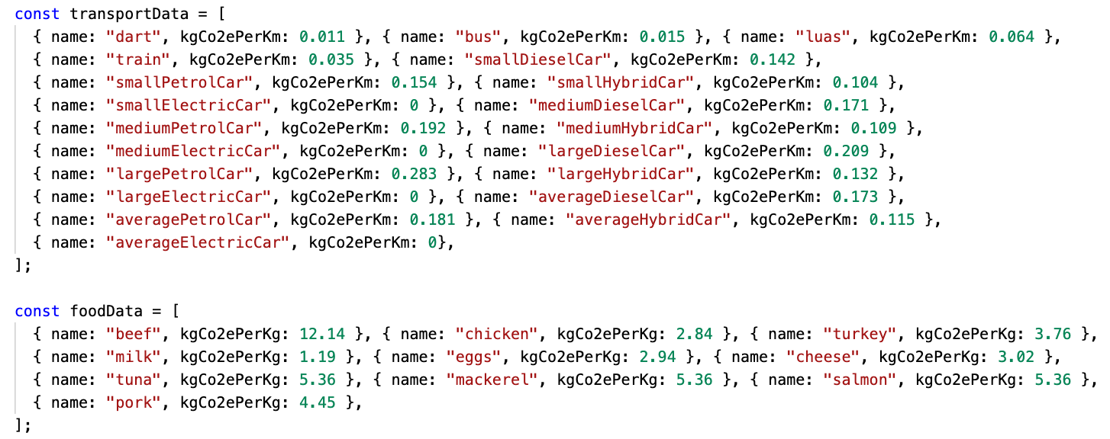

Figure : A map containing co2e emissions for various transport and food activities.

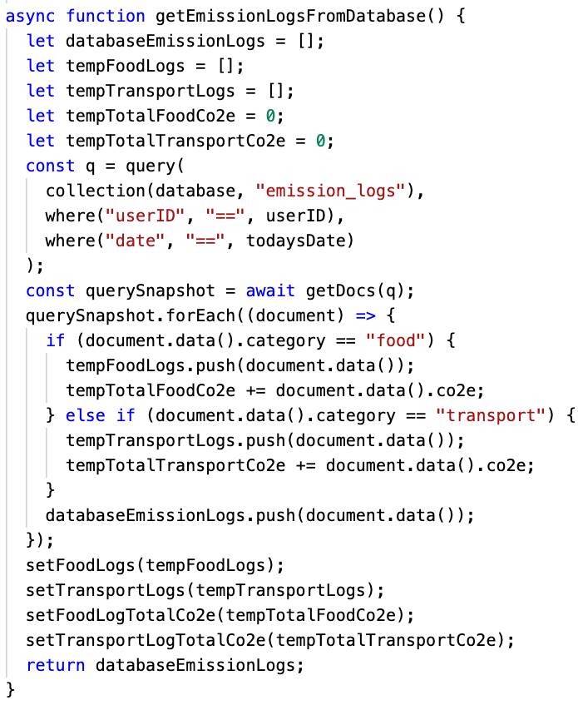The code to retrieve the user’s emission logs for the current day is illustrated in figure 48 below, where the emission_logs collection is queried where the userID matches the logged in user’s ID, and the emission log is for the current day. These logs are then displayed on the homepage.

Figure : Get today's emission logs.

**Score Document**

The score documents could arguably be considered redundant, since they can be calculated from the emission logs of each user. However, the author decided to store them in the database for speed performance of the application. Once the scores have been generated and stored in the database, with figure 49 as an example, these same scores never have to be regenerated. This is particularly important for performance for users viewing the history of their scores, where every score would need to be recalculated, and viewing the individual and team leaderboards, where every single users score would need to be regenerated. Given the use case and expected database calls to be made while using the application, this solution proved optimal.

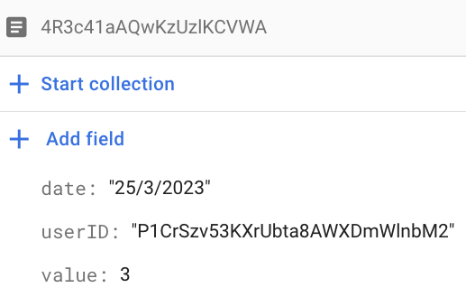

Figure : Example score document.

**Generate Scores for Users for Previous Day**

After a user logs in, the application checks to see if scores for the previous day have been generated. If they have not, scores are generated for users by summing the total co2e emissions from all the previous day’s emission log documents, and converting this total co2e into a score using the co2e score brackets illustrated in figure 51 below. If the scores have already been generated, the block of code is exited. This method of generating scores was implemented because cloud functions to automatically generate scores after midnight each day is not free as per Firebase’s pricing model update. Figures 50 and 51 illustrate the code for generating user scores. The co2e score brackets of 10 to 19kgco2e inclusive were decided based upon the author’s personal footprint when using the application.

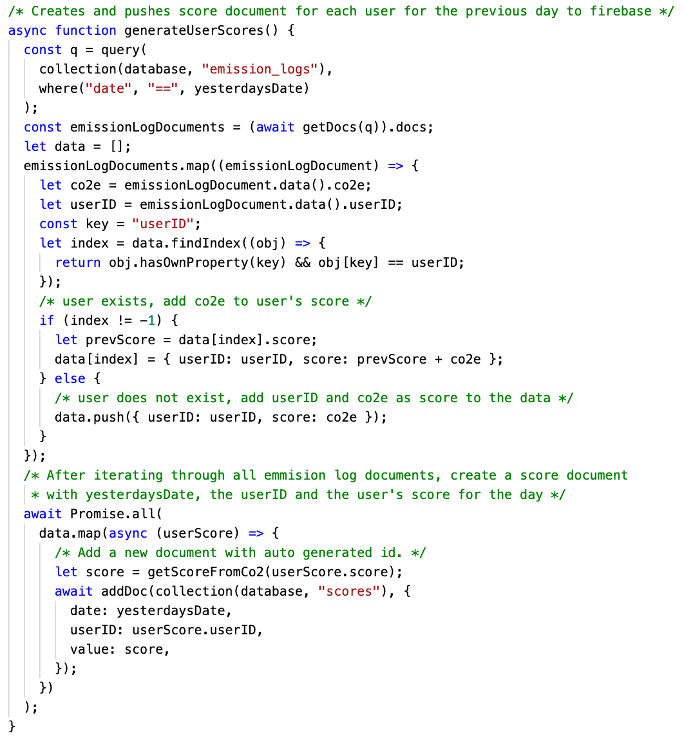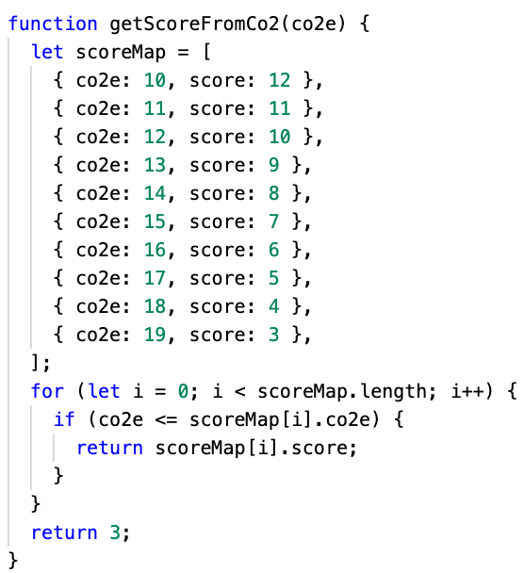

Figure : Co2e score brackets.

Figure : Generate scores for previous day.

**Fetching All User Scores for Individual Leaderboard**

To display the scores in the individual leaderboard, calls are made to the scores collection in Firebase, where every score for the previous day is retrieved, as well as the corresponding user’s name by querying the user collection where the user ID field in the score document matches the ID of the user document, as illustrated in figures 52, 53 and 54 below.

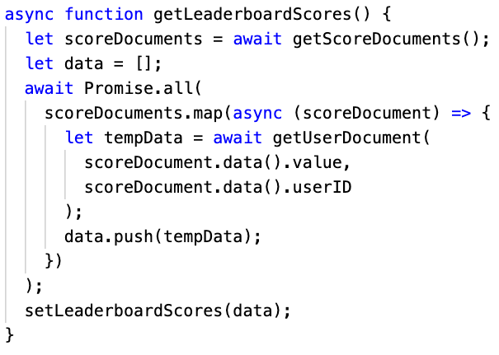

Figure : Get individual leaderboard scores.

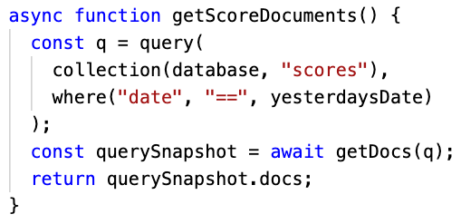

Figure : Get yesterday's score documents.

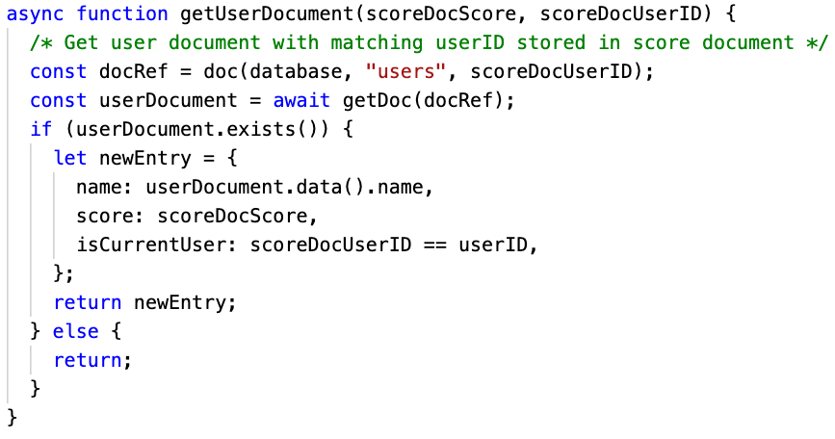

Figure : Get user document.

**Fetching Team Scores for Team Leaderboard**

To display the scores in the team leaderboard, calls are made to the teams collection in Firebase to retrieve the list of teams. Then the combined scores of the team’s members are retrieved by querying the scores collection where the userID field in the score document matches the team members’ IDs, for yesterday’s date. This logic is illustrated in figures 55 and 56 below.

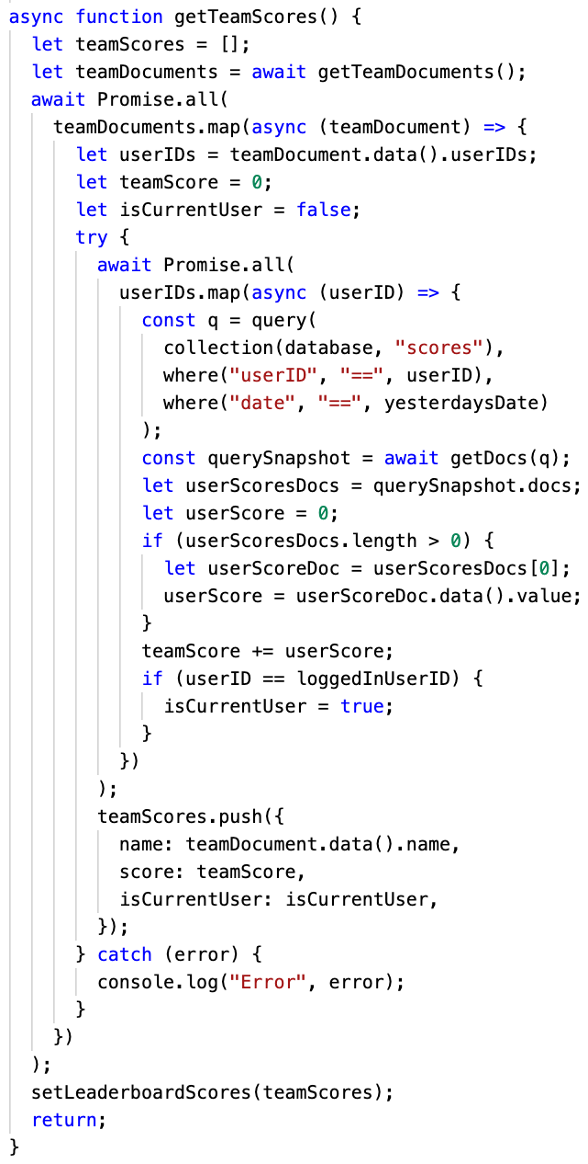

Figure : Get team leaderboard scores.

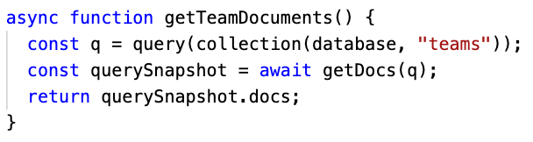

Figure : Get team documents.

­­­

**Fetching Individual Scores for Individual History Screen**

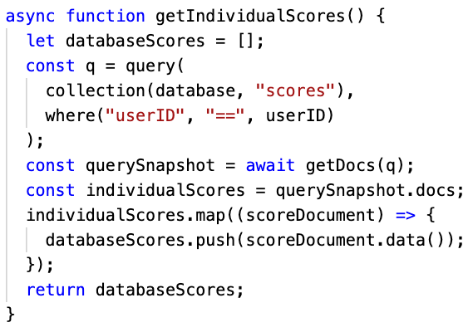To display a user’s history of scores over time, calls are made to the scores collection in Firebase, where every score for the signed in user is retrieved, as illustrated in figure 57 below.

Figure : Get individual scores.

## **Requirements**

The requirements outlined in the design section in chapter 2 of this report were split into 2 categories: functional and non-functional requirements. The below 2 sections discuss whether these requirements were met.

### **Functional Requirements**

The functional requirements outlined in the design chapter in chapter 2 have all been met, as illustrated in the table below:

|  |  |
| --- | --- |
| **Functional Requirement** | **Has been met** |
| Log in | Yes |
| Log food emission | Yes |
| Log transport emission | Yes |
| View history of today’s logs with co2e contribution | Yes |
| Compete in individual leaderboard | Yes |
| Cooperate and compete in team leaderboard | Yes |
| View individual progress chart of scores over time | Yes |

### **Non-functional Requirements**

The non-functional requirements outlined in the design chapter in chapter 2 have all been met, as illustrated in table 3 below:

|  |  |
| --- | --- |
| **Non-functional requirement** | **Has been met** |
| Cross-functional application | Yes |
| Easy to use application | Yes |
| Frequent tasks are performed quickly | Yes |
| Complex tasks’ complexity broken down | Yes |
| Limited likelihood of user errors | Yes |

## **Implementation Issues**

Originally, the author had intended to use Firebase’s Cloud functions to automatically generate user scores at the end of each day for the previous day without having to run the application. Unfortunately, Firebase’s Cloud functions have changed and are no longer provided for free. The solution the author came up with was once the user logs in, check the database to see if a score exists for the previous day and if not generate the scores for each user. All scores will always be generated together, at the same time, thus if a score document does exist then all scores for the previous day have already been created and the code can exit this function without re-fetching the scores.

The novelty of learning React Native was challenging for the author, however this challenge was to be expected and as such the author had accommodated for this, allowing slippage in his project plan.

At times, depending on where the author was working from, the expo simulator would not load or take an absurdly long time to load. Such occurrences happened whilst on campus using the college WIFI or commuting to campus on Dublin Bus using the Dublin Bus WIFI. The author overcame these obstacles by turning on his personal hotspot and connecting to this connection, and planning his workload accordingly. For example, when the author was on campus or on Dublin Bus where the internet may have been inadequate for expo to run, he would utilise this time to focus on the offline workload such as the documentation for this report.

## **Testing**

To test the application, console logs were frequently used to view any discrepancies between expected and actual performance. By strategically inserting console log statements throughout the code base, the author was able to pinpoint the location of any bugs in the code, aiding the speed at which these bugs could be resolved. Console logs were particularly useful when the code needed to wait for data to be retrieved from the database before proceeding.

Figure 58 below illustrates an example of the codebase where the author utilised console logs for testing purposes when retrieving information from the database. In figure 59, the author was expecting the console, or terminal, to log the sequence “123”, however, as can be seen from figure 59 below, the sequence was in fact “132”. This allowed the author to pinpoint the problem which was that the code was not waiting for the data to be retrieved. By utilising console logs for testing this function, the author was able to remedy the code as illustrated in figures 60 and 61 below with the improved code and the desired sequence of “123”.

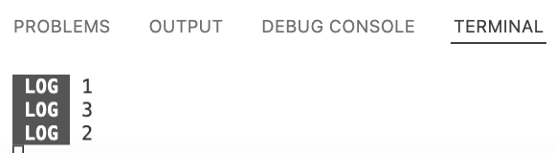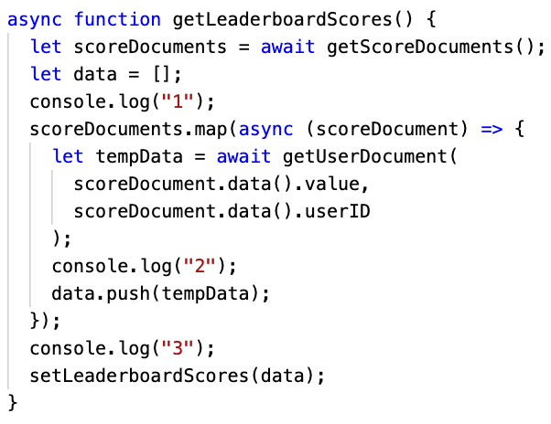

Figure : Example of testing code using console logs. The sequence printed should be 123.

Figure : Output from running code in figure1. Sequence expected is 123, but actual output was 132. Thus, a bug has been identified.

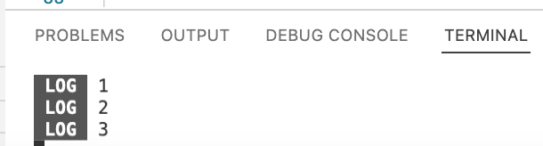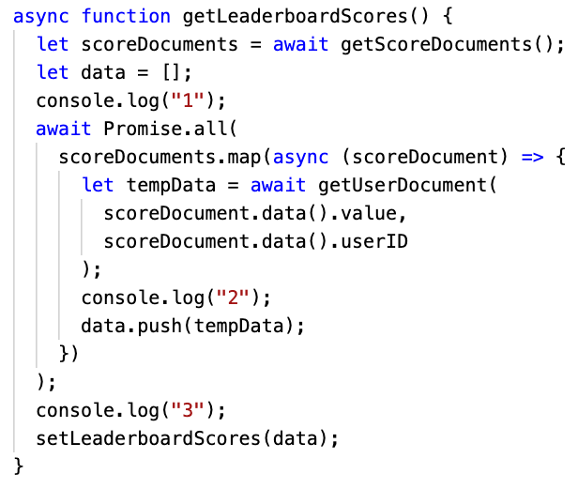

Figure : Updated code where “await Promise.all(…” has been added. Again, the expected output should be 123.

Figure : The sequence printed from figure 3, illustrating that the bug has been fixed since the sequence 123 matches the desired output.

# **Evaluation & Discussion**

This chapter discusses the evaluation and discussion of the project, where the evaluation method and findings will be highlighted, as well as a discussion on the overall impact this application had on the environmental knowledge-action gap problem identified in chapter 1 of this report.

## **Evaluation**

In this section, the rationale for and findings of using the method of questionnaires about participants motivation levels before and after using the application and about application performance, as well as analysing any change in participants’ carbon footprint scores over time will be discussed.

### **Method**

To evaluate the application built for this project, the author decided to utilise a combination of questionnaires and analysing realised user data. The author decided to utilise questionnaires and specifically questions following the LIKERT format, answering questions on a scale of 1-10 because this method facilitates collecting information on participants’ motivation levels before and after using the application. Additionally, questionnaires are an inexpensive, efficient and quick means of collecting high volumes of information from participants, being particularly effective for measuring qualitative data such as participants motivation levels, attitudes and willingness to reduce individual carbon footprints (Lund, T. (2011)). The author decided on the method of analysing realised carbon footprint scores from user data after having used the application because this method provides quantitative insights into the effect of this application, adding an additional perspective and means to evaluate the application (Lund, T. (2011)).

In order to conduct and analyse data from questionnaires and users having used the application, the author applied and received ethical approval from the Trinity College Dublin Ethics Committee. A copy of the application is included in the appendix section at the end of this report, namely appendix 8.4, as well as a copy of the questionnaires sent to participants, namely appendices 8.5 and 8.6.

### **Questionnaire Responses**

Before trialling the application, participants were asked to answer questions relating to their motivation to reduce their individual carbon footprint and provide reasons for their level of motivation. Copies of the questionnaires are attached in the appendix at the end of this report, namely appendices 8.5 and 8.6. The results of the responses from the 10 participants revealed that of the 10 participants, only 2 responded with a motivation level of 3 or more prior to using the application. Popular reasons for such little motivation were a feeling of negligible individual impact, difficulty in seeing the benefit or consequences of your environmental actions and a feeling of no personal reward in return for sacrifices or changing your environmental actions.

After 7 days of using the gamified, social mobile application in this project, participants were again asked to answer questions about their motivation levels. The results indicate that of the 10 participants involved in this study, after using the gamified social mobile application, 6 participants reported increased motivation levels, between the ranges of 6-8 out of 10 for their level of motivation. This is an increase in motivation levels above 3 out of 10 from 2 to 6 participants, a 200% increase. This increase is illustrated in figure 62 below.

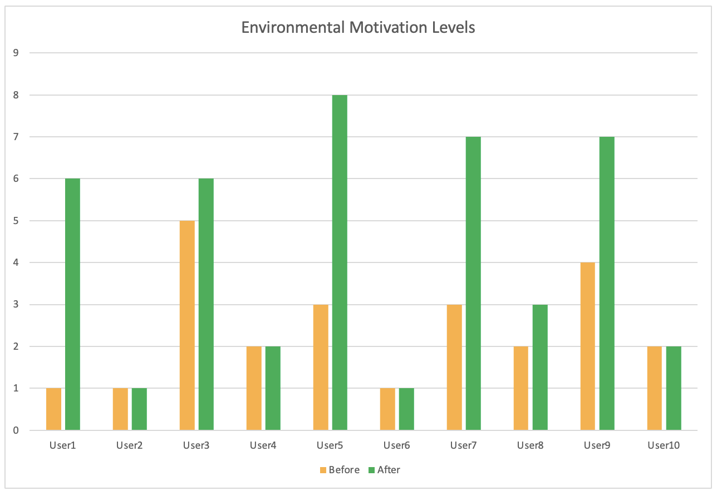

Figure : Bar chart illustrating the change in motivation levels to reduce individual carbon footprint after using the application in this project.

Additionally, to collect qualitative data about the performance or rating of the application, users were asked in the questionnaire to rate the ease of use, likelihood of running into errors, complexity of tasks and the speed at which they could perform frequent tasks. Figure 63 below illustrates these average ratings, where ease of use and speed of performing frequent tasks received a score of 8 out of 10 and 9 out of 10 respectively, with 10 being the best possible score. The likelihood of running into errors and complexity of tasks were rated as 3 and 2 out of 10 respectively, with 1 being the best possible score.

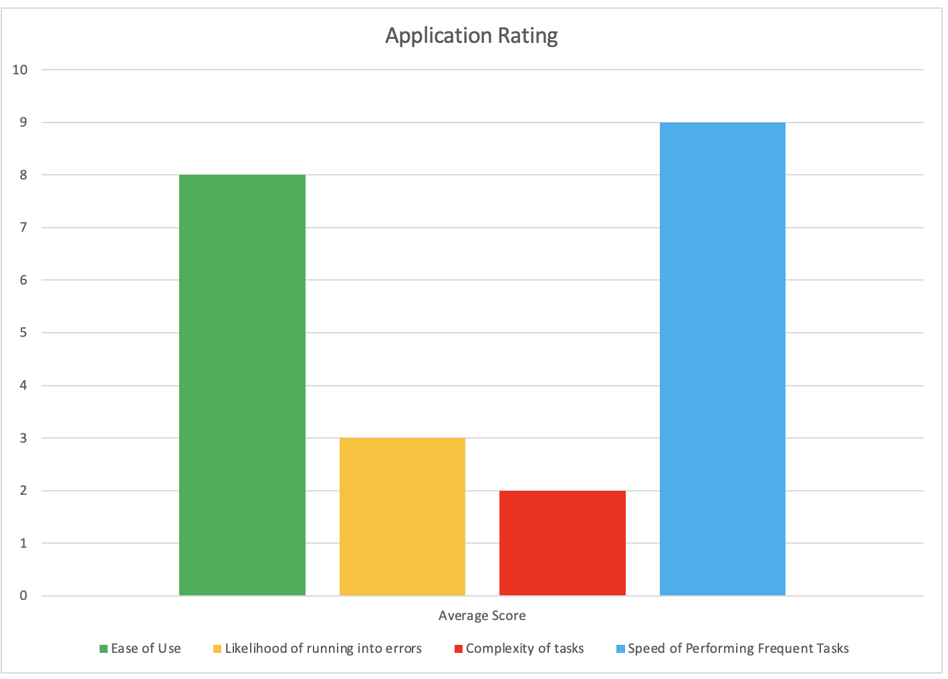

Figure : Average ratings for important application aspects as rated by the participants of the application.

When asked to respond as to why their level of motivation had or had not increased, participants responded by saying the feeling of mutual accountability in the cooperation aspect of the game, the team leaderboard, was a source of motivation. In this case, participants attributed this motivation to the feeling of a social etiquette, and responsibility to not let your teammate down, and that helping the environment was not the reason for wanting to reduce individual carbon footprints. Participants further divulged that by viewing their individual scores over time they could visually see their performance, motivating them to improve their scores, or not to decline in scores.

With the ability to view the breakdown of their daily emission logs, participants reported these breakdowns to facilitate learning, aiding them in reducing their carbon footprints where one user reported changing his commute to training from driving solo, to carpooling with a teammate. Another user reported after realising the carbon footprint produced by consuming beef in comparison to chicken, decided to substitute beef for chicken for his dinner on two occasions.

When asked about their overall experience using the application, all 10 participants reported running into no errors in the application, felt the most frequent tasks could be completed quickly and that no task was overly complex.

When asked about their overall experience, all participants reported enjoyment using the application, referencing the clear layout and navigation of the application to be very user friendly and easy to use.

### **Changes in Carbon Footprint Scores**

While the questionnaires provided insights into whether users felt an increase in motivation to reduce their individual carbon footprints, and why, the realised carbon footprint scores of the participants, that is, the tangible reduction, increase or consistency in their carbon footprints, provides insights into whether meaningful action was taken, or did participants only feel motivation but did not actually take meaningful action by reducing their carbon footprints.

Upon analysing the data, 4 out of 10 users exhibited a realised decrease in their individual carbon footprints between the first and last days’ carbon footprints. With 6 participants reporting increased motivation levels, this leaves 2 participants with increased motivation but not a realised reduction in their carbon footprints. Feedback from questionnaires provided answers whereby users felt motivated, but that by already engaging in environmentally friendly actions such as taking the bus to work and eating a carbon-friendly diet, they found it difficult to reduce their footprint. With 6 out of 10 users seeing no improvement in realised carbon footprints, certainly not all participants were affected to the same extent.

## **Discussion**

This section discusses the overall effect building this application had on tackling the problem of a knowledge action gap towards reducing individual carbon footprints identified as the motivation and goal for this project in the introduction chapter in chapter 1.

### **Solving the Environmental Knowledge Action Gap Problem**

The environmental knowledge action gap identified in chapter 1, and carried forward as the motivation for this project, is not completely solved because this gap has developed over hundreds of years, and as such, cannot be solved in such a short time span. However, the results indicate a step in the right direction, and by a shifting of approach to motivating a reduction in individual carbon footprints and thus an increase in pro-environmental action through effective message frames which satisfy the psychological user needs of autonomy, competence and relatedness, this increase in motivation and thus pro-environmental action will compound over time, with the hopes of drastically reducing this detrimental gap. The environmental knowledge action gap has been reduced through building this application, but still has room for further reduction.

### **What Worked and What did not Work**

The research discussed in the literature review highlighted the need to satisfy the psychological user needs of autonomy, competence and relatedness as illustrated by the self-determination theory, and the need to reframe message frames from altruistic to self-enhancing, targeting personal gain for those to be motivated, as illustrated by the Inclusion Model for Environmental Concern. Additionally, achievement and social gamification features were emphasised as an effective way to satisfy these psychological user needs of autonomy, competence and relatedness.

**What Worked**

* Reframing message frames to focus on self-enhancing values increased motivation to reduce individual carbon footprints for the majority of users (6 out of 10).
* Targeting psychological user needs of autonomy, competence and relatedness outlined by self-determination theory proved important.
* The social and achievement gamification features implemented proved to satisfy all 3 psychological user needs of autonomy, competence and relatedness for the majority of users (6 out of 10).
* Users began to behave pro-environmentally without even realising they were doing so.
* 4 out of 10 users saw a reduction in individual carbon footprints.

**What did not Work**

* The minority of users (4 out of 10) saw little to no change in motivation due to not valuing competition or winning as important to them.
* The social and achievement gamification features implemented did not satisfy all 3 psychological user needs of autonomy, competence and relatedness for the minority of users (4 out of 10).
* A realised reduction in individual carbon footprints was not demonstrated by 6 out of 10 users.

The fact that not all users were motivated to reduce their individual carbon footprint reiterates the point made in the literature review when analysing existing solutions of Ant Forest and Green Life, that effective design is crucial to achieve increased motivation, and the dangers of assuming gamification will motivate pro-environmental behaviour. The need to address psychological user needs of autonomy, competence and relatedness and to reframe message frames as providing personal gain remain accurate, however, the danger here lies in assuming all users’ psychological needs of autonomy, competence and relatedness will be satisfied by the same gamification features. Clearly, the particular personal gain emphasised in the self-enhancing message frame of the application will not appeal equally to all users. A variety of users thus requires a variety of self-enhancing message frames.

By analysing the evaluation of the application, the application has proven to be successful in terms of reducing individual carbon footprints and thus reducing the environmental knowledge-action gap outlined in the goals and objectives in chapter 1. This problem is by no means solved, however, this application is an example of how gamification and effective message framing can be used to address the environmental knowledge-action gap problem.

# **Conclusion**

This chapter addresses the limitations of the study, areas for future work and finally the author’s reflection on his overall experience of this project, divulging what he has learned, is proud of, found challenging and what his favourite part was.

## **Limitations of the Project**

The limitations for the project were time constraints, the short duration of the study, the small participant size used in the study, difficulty in sourcing emissions data and a lack of financial aid.

**Time Constraints**

Time constraints proved to be the most limiting factor of this project. To overcome this inevitable limitation, the author began to plan the workload early and reassess the plan against the progress made after each fortnight. Planning can be seen in appendices 8.1, 8.2 and 8.3. A tremendous aid in accommodating for the time constraints presented by this project was to incorporate slippage into the plan of work, whereby if the author estimated a piece of work would take, for example, 10 days, to shield himself against the ramifications of missed deadlines, he added an additional 2 days to the estimation to make it 12 days, catering for running into any unforeseen circumstances. Additionally, having identified the different deliveries for the project and their dependencies, the author was able to plan what work to do while waiting for aspects such as responses from participant questionnaires or collecting data from users. While waiting for this collection of data, the author focused on writing the documentation for this report.

**Short Duration to Test the Application**

Another limitation of this project was the short duration to test the application, where participants only tested the application over a 7 day period. With the limited time constraints in place, a longer duration to test the application was not feasible. This short, 7-day duration of testing the application is a limitation because the effect of the application on environmental motivation levels and thus reductions in individual carbon footprints may change over time. The study does not provide insight into if the results seen in chapter 5 on evaluation will remain the same over time, where users may discontinue using the application after the novelty of the application wears off, or contrastingly, users may need more time to adapt their food and transport activities, where further reductions in individual carbon footprints could be seen as time progresses. The current project provides insights into the effects after a 7 day period, but this is not necessarily an accurate indication for long term use.

**Small Participant Size**

The small participant size of using only 10 participants is a limitation of the study, because, as previously revealed in the evaluation chapter, in chapter 5, different participants require different self-enhancing message frames. As such, one cannot assume the 10 participants involved in this study are indicative of society as a whole. What motivated or did not motivate some participants, may have the opposite motivational effect on other members of society who did not participate in this study. One could argue that given a different sample of 10 participants, the results could have been completely different in terms of motivating pro-environmental behavioural change and thus a reduction in individual carbon footprints.

**Sourcing Emissions Data**

Sourcing data on Irish carbon footprint emissions for specific activities proved to be a limitation of the study. To address this limitation, where Irish data was not available, the author collected data from the UK government, the closest substitute to Irish data.

**Lack of Financial Aid**

Another limitation of this project was the lack of financial aid. However, this was a very small limitation, only surfacing in one instance where the author had planned on using Firebase’s Cloud functions to automatically generate carbon footprint scores for a user for the previous day at 00:01. These cloud functions were historically free for users, but Firebase decided to update their pricing plan and these cloud functions must now be paid for. To overcome this limitation, the author applied his creativity to check if the database contained a score for the previous day when the user signs in, and if no score exists then the scores are generated, and if a score does exist, the loop exists and proceeds as normal.

## **Future Work**

Having identified the limitations of the project in the previous section, areas for future work to enhance this project are primarily to address some of these limitations, namely: testing the application with a larger participant size and testing the application for a longer time period. Additional areas for future work are continuing research into the different types of self-enhancing message frames and their effectiveness, and to further develop this application with areas which were not implemented due to time constraints of the project.

**Larger Participant Size**

As already discussed in the previous section on the limitations of this project, the results presented in the evaluation chapter in chapter 5 cannot truly analyse the effect of this application on society as a whole, since the participant size of 10 participants is not indicative of the entirety of society, where different users respond to various self-enhancing message frames differently. As such, an area for future work is to test the application with a larger participant size to increase accuracy in determining the effect this gamified application can have on society as a whole.

**Longer Time Period**

As revealed by the previous section on limitations of this project, having participants only test the application over a 7 day period was another limitation of this project, since there is no evidence to test the sustainability of the application’s ability to motivate pro-environmental behavioural change. To address this limitation, an area for future work is to test the application for a longer time period to further increase accuracy of the effect of this application on motivating pro-environmental behavioural change and thus reducing individual footprints.

**Continue Research into Effectiveness of Different Self-Enhancing Message Frames**

The literature review discussed in chapter 2 indicates that self-enhancing message frames are crucial to motivate pro-environmental behavioural change, however, the results presented in this project indicate that not all users respond equally to the same self-enhancing message frames. Further research could be undertaken to examine the most effective self-enhancing message frames.

**Further Develop the Application**

During implementation, the features considered to add the most value were prioritised. Features which were dedicated to future work which can further develop the application are briefly discussed in the table below:

|  |  |
| --- | --- |
| **Feature** | **Comment** |
| Sign up | The author deferred the ability to sign up because new sign-ups add unnecessary complexity to the team leaderboard, where new users would need to be placed in teams of equal size. The author prioritised providing an environment to compete in through pre-defined teams, since actually competing is the important feature to address the psychological user needs of autonomy, competence and relatedness, not selecting or creating teams. |
| Create a team | Deferred for the same reason as the sign up feature, where the impact of creating a team on motivating pro-environmental behavioural change is negligible. |
| Join a team | Deferred for the same reason as the create a team and sign up features, where the impact of selecting what team to join is negligible. Simply being part of a team satisfies the psychological user needs of autonomy, competence and relatedness, not selecting which team. |
| Edit or delete an emission log | The confirmation button users are presented with after attempting to log an emission should be sufficient to prevent the need to edit or delete an emission log. As highlighted by the design chapter in chapter 3, the author prioritised preventing errors as opposed to treating realised errors. |
| Quick-add an emission log | To speed up the frequent task of logging an emission which the user logs daily, such as the same daily breakfast and commute to work, a quick-add option could be added. This was not prioritised because the user can still complete their emission log without this feature. |
| QR code scanner to log food | Similarly to a quick-add option, a QR code scanner would speed up logging a food log for users. As with all of the features in this table, due to time constraints this QR code scanner feature was deferred. |

Although these features were not implemented due to time constraints and prioritisation of the most value adding features, the author is satisfied that the overall goal for this project of providing a gamified, social mobile application to increase motivation to reduce individual carbon footprints, and thus reduce such footprints, has been accomplished and delivered effectively.

## **Reflection**

This section reflects on the project as a whole, discussing what the author learned, is proud of, found challenging, and his favourite part.

### **What the Author Learned**

Throughout this process, the author has developed a multitude of new skills, as well as improving existing skills. These new learnings consist of a plethora of new software skills such as front-end mobile application development using React Native, as well as creating and connecting a Firebase database to the front end of the mobile application.

Additionally, the author has enhanced his academic writing skills, demanding the ability to develop coherent thoughts, structure content accordingly and to plan the overall delivery of the thesis as a whole, taking other commitments into consideration.

### **Proud Of**

What the author was most proud of, was his ability to connect and integrate learnings from his four years in college into 1 large capstone. Prior to this project, the author felt his skills in database design, user interface design and user experience design were all fragmented, having only experienced these fields in separate, one dimensional projects. Having built this gamified social mobile application, the author has gained an understanding and experience with regards to connecting the different aspects needed for a comprehensive mobile application.

Additionally, this was the author’s first time using Firebase, providing the author with great pride in his delivery of a successful database integration. The author had previously studied best practices for designing databases, but had never connected an application to an online database.

### **Found Challenging**

By far, the most challenging aspect the author experienced was sourcing data for carbon dioxide emissions for specific activities. The application developed for this project focused on Irish emissions data, however, when Irish emissions data was difficult to source, the author had to find not only an alternative source, but an appropriate substitute for Irish emissions. To overcome this challenge, the author researched UK emissions and was relieved to find the UK government provides emissions for transport activities. While Irish emissions focus on the country as a whole and emissions from a full sector such as transport, UK emissions data provide insights into the emissions for different car sizes, fuel types and distance travelled. Although sourcing emissions proved challenging, overcoming this obstacle produced a great level of achievement, accomplishment and satisfaction to the author.

### **Favourite Part**

Being a computer science and business student, the author has tremendous experience in developing code for applications to solve various problems. Where the author had limited experience prior to this project was surrounding the importance of why an application should be developed. Having undertaken extensive research for the literature review, and the project as a whole, the author gained an appreciation for establishing what value, purpose and impact developing an application can have, and that in order for the developed application to be meaningful, it must provide a foundational value, purpose or impact to its users. From building this application, the author observed that having established the purpose and value that would be delivered by the completed application proved to be a great, sustained motivation throughout this project, adding to the author’s overall enjoyment of this experience.

## **Conclusion**

Overall, the author is satisfied that the goals and objectives of this project to gamify carbon footprints to motivate pro-environmental behavioural change have been delivered based on the results and data collected, which is discussed in chapter 5 on evaluation. Having undertaken extensive research in the areas of carbon footprints, behavioural psychology and gamification for the literature review, investigated an effective design for the gamified, social mobile application, implemented this application and conducted evaluation through questionnaires and analysing users’ carbon footprint scores over time, all within the limited time constraints of this project, the author takes immense pride in what he has accomplished with this project. Additionally, the author takes great pride in having contributed to the global need to reduce the knowledge action gap towards reducing individual carbon footprints.

# **References**

Annetta, L.A. (2010) “The ‘I's’ have it: A framework for serious educational game design,” Review of General Psychology, 14(2), pp. 105–113. Available at: https://doi.org/10.1037/a0018985.

Bormann, D. and Greitemeyer, T. (2015) “Immersed in virtual worlds and minds,” Social Psychological and Personality Science, 6(6), pp. 646–652. Available at: https://doi.org/10.1177/1948550615578177.

Bouman, T., Steg, L. and Zawadzki, S.J. (2020) “The value of what others value: When perceived biospheric group values influence individuals’ pro-environmental engagement,” Journal of Environmental Psychology, 71. Available at: https://doi.org/10.1016/j.jenvp.2020.101470.

Cao, Y. et al. (2022) “How gamified cooperation and competition motivate low-carbon actions: An investigation of gamification in a popular online payment platform in China,” Journal of Environmental Management, 324. Available at: https://doi.org/10.1016/j.jenvman.2022.116259.

Comyn, P. (2009) Surprise carbon offenders, The Irish Times. The Irish Times. Available at: https://www.irishtimes.com/life-and-style/motors/surprise-carbon-offenders-1.765821 (Accessed: February 14, 2023).

De Dominicis, S., Schultz, P.W. and Bonaiuto, M. (2017) “Protecting the environment for self-interested reasons: Altruism is not the only pathway to sustainability,” Frontiers in Psychology, 8. Available at: https://doi.org/10.3389/fpsyg.2017.01065.

Department for Energy Security and Net Zero (2020) Greenhouse gas reporting: Conversion factors 2019, GOV.UK. GOV.UK. Available at: https://www.gov.uk/government/publications/greenhouse-gas-reporting-conversion-factors-2019 (Accessed: February 14, 2023).

Deterding, S. et al. (2011) “From game design elements to gamefulness,” Proceedings of the 15th International Academic MindTrek Conference: Envisioning Future Media Environments [Preprint]. Available at: https://doi.org/10.1145/2181037.2181040.

Environmental Protection Agency (EPA) (2022) Ireland’s Provisional Greenhouse Gas Emissions 1990-2021. Available at: https://www.epa.ie/publications/monitoring--assessment/climate-change/air-emissions/EPA-Ireland's-Provisional-GHG-Emissions-1990-2021_July-2022v3.pdf (Accessed: January 6, 2023).

Fielding, K.S. and Hornsey, M.J. (2016) “A social identity analysis of climate change and environmental attitudes and behaviors: Insights and opportunities,” Frontiers in Psychology, 7. Available at: https://doi.org/10.3389/fpsyg.2016.00121.

Francisco-Aparicio, A. et al. (2013) “Gamification: Analysis and application,” Human–Computer Interaction Series, pp. 113–126. Available at: https://doi.org/10.1007/978-1-4471-5445-7_9.

Gartner (2012) Gartner says by 2014, 80 percent of current gamified applications will fail to meet business objectives primarily due to poor design., Gartner. Available at: http://www.gartner.com/it/page.jsp?id=2251015.

Gifford, R. (2011) “The dragons of inaction: Psychological barriers that limit climate change mitigation and adaptation.,” American Psychologist, 66(4), pp. 290–302. Available at: https://doi.org/10.1037/a0023566.

Gifford, R. (2013) “Dragons, mules, and honeybees: Barriers, carriers, and unwitting enablers of climate change action,” Bulletin of the Atomic Scientists, 69(4), pp. 41–48. Available at: <https://doi.org/10.1177/0096340213493258>.

Gokgoz, Z.A., Ataman, M.B. and van Bruggen, G.H. (2021) “There’s an application for that! understanding the drivers of mobile application downloads,” Journal of Business Research, 123, pp. 423–437. Available at: https://doi.org/10.1016/j.jbusres.2020.10.006.

Griskevicius, V., Tybur, J.M. and Van den Bergh, B. (2010) “Going green to be seen: Status, reputation, and conspicuous conservation.,” Journal of Personality and Social Psychology, 98(3), pp. 392–404. Available at: https://doi.org/10.1037/a0017346.

Jans, L., Bouman, T. and Fielding, K. (2018) “A part of the energy \‘in crowd\": Changing People's Energy Behavior via group-based approaches,” IEEE Power and Energy Magazine, 16(1), pp. 35–41. Available at: https://doi.org/10.1109/mpe.2017.2759883.

Kenny, T. and Gray, N.F. (2009) “Comparative performance of six carbon footprint models for use in Ireland,” Environmental Impact Assessment Review, 29(1), pp. 1–6. Available at: https://doi.org/10.1016/j.eiar.2008.06.001.

Kim, K. et al. (2015) “Is it a sense of autonomy, control, or attachment? exploring the effects of in-game customization on game enjoyment,” Computers in Human Behavior, 48, pp. 695–705. Available at: https://doi.org/10.1016/j.chb.2015.02.011.

Koivisto, J. and Hamari, J. (2019) “The rise of Motivational Information Systems: A review of Gamification Research,” International Journal of Information Management, 45, pp. 191–210. Available at: https://doi.org/10.1016/j.ijinfomgt.2018.10.013.

Kraus, S., Mahto, R.V. and Walsh, S.T. (2021) “The importance of literature reviews in Small Business and Entrepreneurship Research,” Journal of Small Business Management, pp. 1–12. Available at: https://doi.org/10.1080/00472778.2021.1955128.

Lund, T. (2011) “Combining qualitative and quantitative approaches: Some arguments for mixed methods research,” Scandinavian Journal of Educational Research, 56(2), pp. 155–165. Available at: https://doi.org/10.1080/00313831.2011.568674.

Mulrow, J. et al. (2019) “The state of carbon footprint calculators: An evaluation of calculator design and user interaction features,” Sustainable Production and Consumption, 18, pp. 33–40. Available at: https://doi.org/10.1016/j.spc.2018.12.001.

Nolan, J.M. and Schultz, P.W. (2013) “Prosocial behavior and environmental action,” Oxford Handbooks Online [Preprint]. Available at: https://doi.org/10.1093/oxfordhb/9780195399813.013.011.

Peng, W. et al. (2012) “Need satisfaction supportive game features as motivational determinants: An experimental study of a self-determination theory guided exergame,” Media Psychology, 15(2), pp. 175–196. Available at: https://doi.org/10.1080/15213269.2012.673850.

Rigby, S. and Ryan, R.M. (2011) “Glued to games: How video games draw us in and hold us spellbound,” Choice Reviews Online, 49(01). Available at: https://doi.org/10.5860/choice.49-0099.

Ronayne, D., Sgroi, D. and Tuckwell, A. (2021) How susceptible are you to the sunk cost fallacy?, Harvard Business Review. Available at: https://hbr.org/2021/07/how-susceptible-are-you-to-the-sunk-cost-fallacy (Accessed: February 5, 2023).

Ryan, R.M. and Deci, E.L. (2000) “Self-determination theory and the facilitation of intrinsic motivation, social development, and well-being.,” American Psychologist, 55(1), pp. 68–78. Available at: https://doi.org/10.1037/0003-066x.55.1.68.

Ryan, R.M., Rigby, C.S. and Przybylski, A. (2006) “The motivational pull of video games: A self-determination theory approach,” Motivation and Emotion, 30(4), pp. 344–360. Available at: https://doi.org/10.1007/s11031-006-9051-8.

Sailer, M. et al. (2017) “How gamification motivates: An experimental study of the effects of specific game design elements on psychological need satisfaction,” Computers in Human Behavior, 69, pp. 371–380. Available at: https://doi.org/10.1016/j.chb.2016.12.033.

Sanchez-Sabate, R. and Sabaté, J. (2019) “Consumer attitudes towards environmental concerns of meat consumption: A systematic review,” International Journal of Environmental Research and Public Health, 16(7), p. 1220. Available at: https://doi.org/10.3390/ijerph16071220.

Schwenkenbecher, A. (2014) “Is there an obligation to reduce one's individual carbon footprint?,” Critical Review of International Social and Political Philosophy, 17(2), pp. 168–188. Available at: <https://doi.org/10.1080/13698230.2012.692984>.

United Nations Climate Change (2015) The Paris Agreement., Unfccc.int. Available at: https://unfccc.int/process-and-meetings/the-paris-agreement (Accessed: February 3, 2023).

Wei, M. et al. (2005) “Adult attachment, shame, depression, and loneliness: The mediation role of basic psychological needs satisfaction.,” Journal of Counseling Psychology, 52(4), pp. 591–601. Available at: https://doi.org/10.1037/0022-0167.52.4.591.

Westhoek, H. et al. (2014) “Food choices, health and environment: Effects of cutting Europe's meat and dairy intake,” Global Environmental Change, 26, pp. 196–205. Available at: https://doi.org/10.1016/j.gloenvcha.2014.02.004.

Wiedmann, T. and Minx, J. (2007) “A Definition of 'Carbon Footprint',” in Ecological Economics Research Trends. New York: Nova Science Publishers, pp. 1–11.

Xi, N. and Hamari, J. (2019) “Does gamification satisfy needs? A study on the relationship between gamification features and intrinsic need satisfaction,” International Journal of Information Management, 46, pp. 210–221. Available at: https://doi.org/10.1016/j.ijinfomgt.2018.12.002.

# **Appendix**

## **Plan of Work**

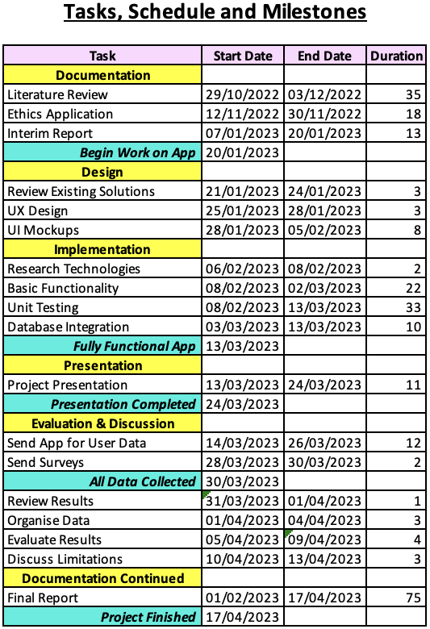

## **Dependencies**

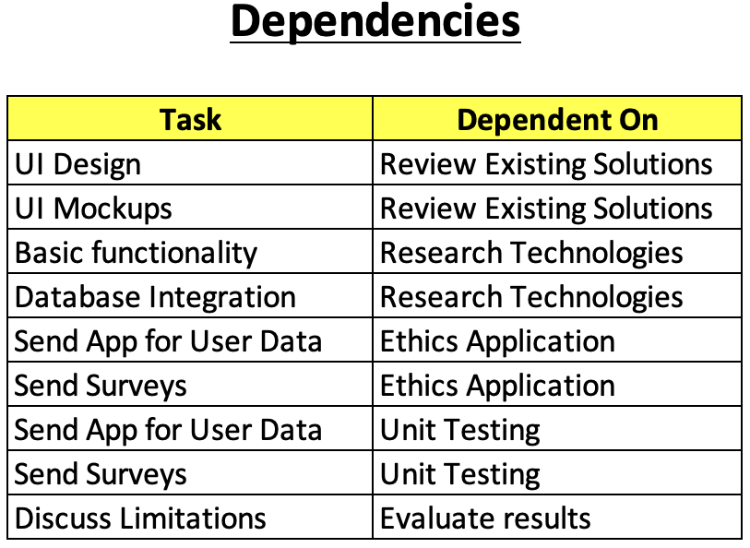

**Gantt Chart**

## **Ethics Application Forms**

### **Ethics Application Form**



Figure : Ethics application form part 1.

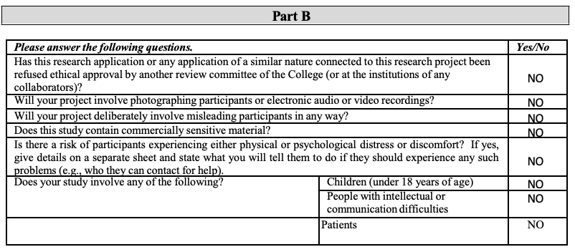

Figure : Ethics application form part 2.

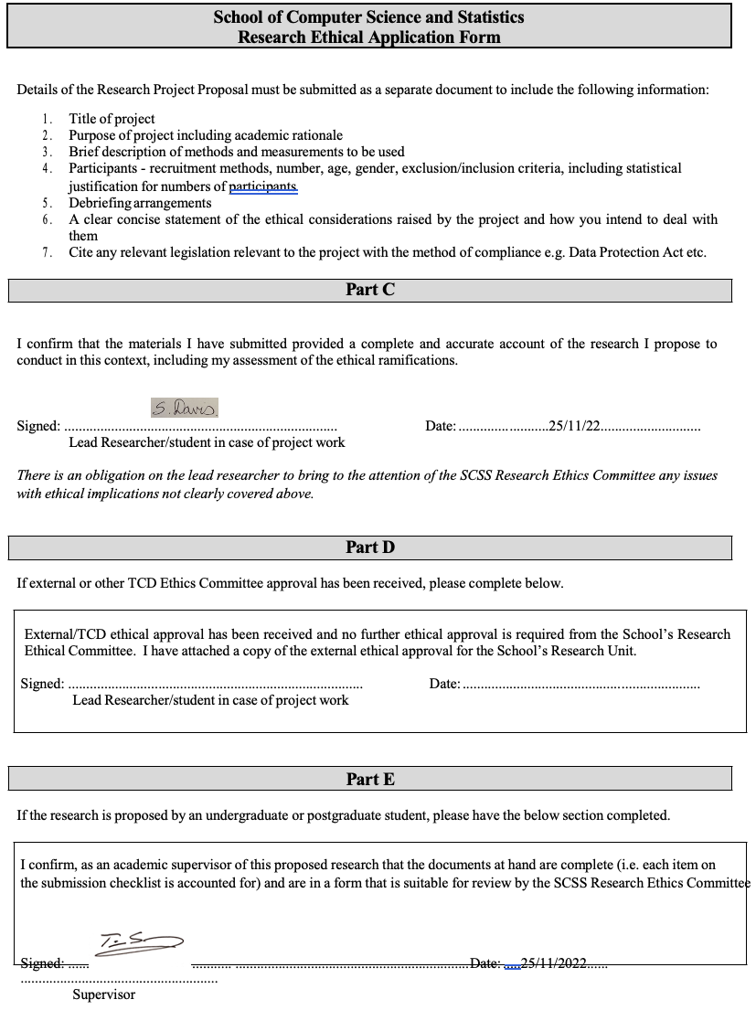

Figure : Ethics Application Form part 3.

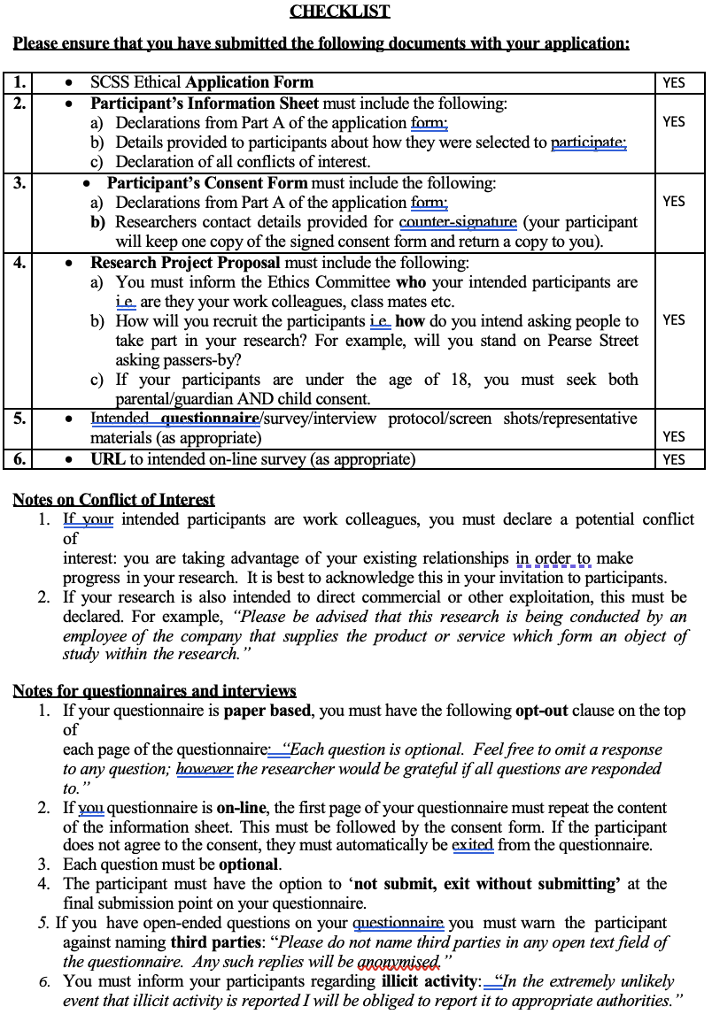

Figure : Ethics Application Form part 4.

**Informed Consent Form**

Figure : Informed Consent Form part 1.



Figure : Informed consent form part 2.

### **Information Sheet for Prospective Participants**

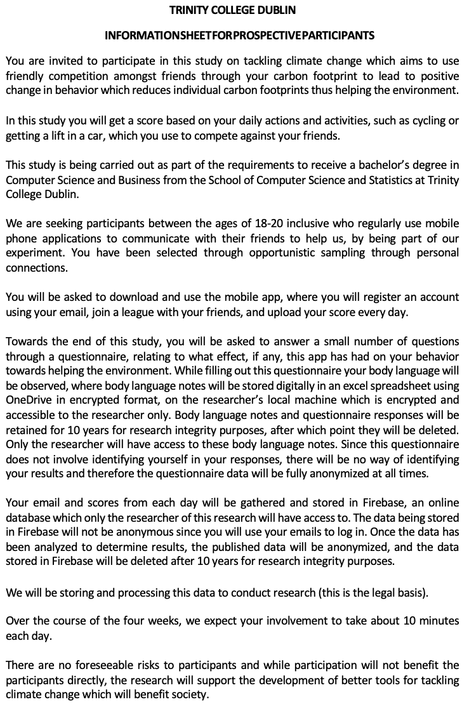

Figure : Information sheet part 1.

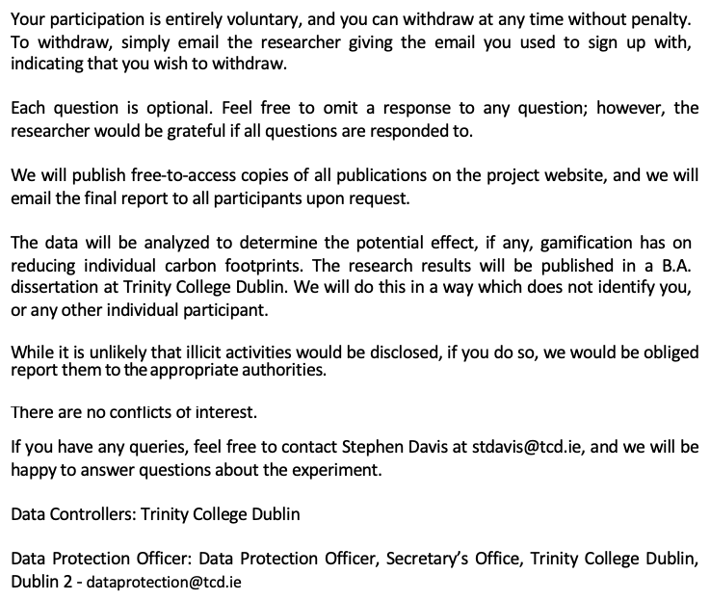

Figure : Information sheet part 2.

### **Details of Research Project**

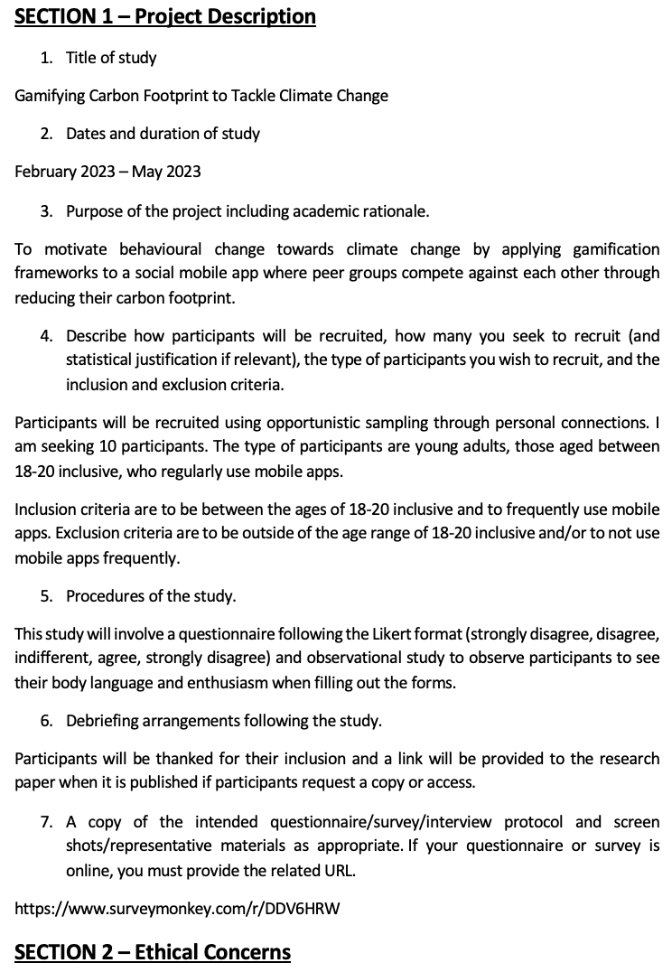

Figure : Ethics Proposal part 1.



Figure : Ethics proposal part 2.

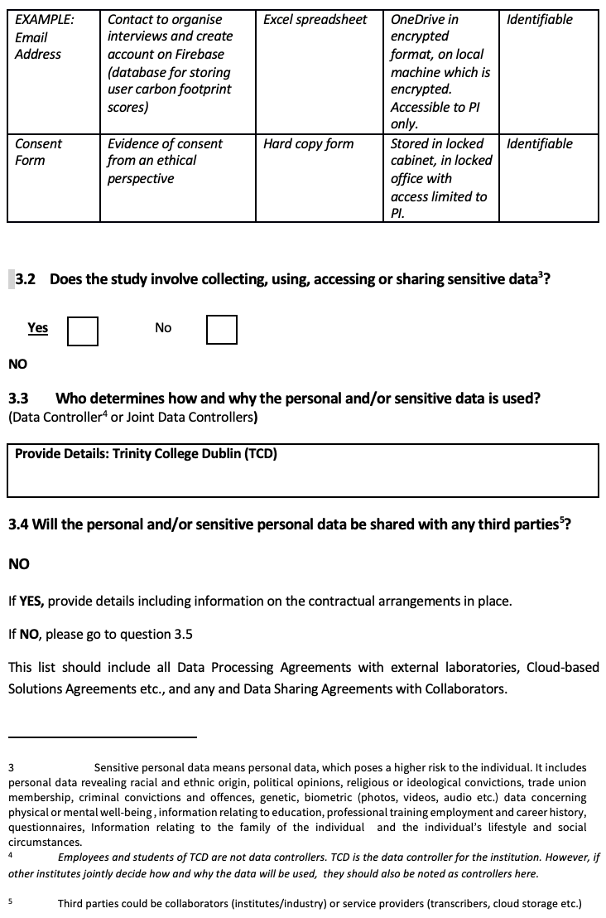

Figure : Ethics proposal part 3.

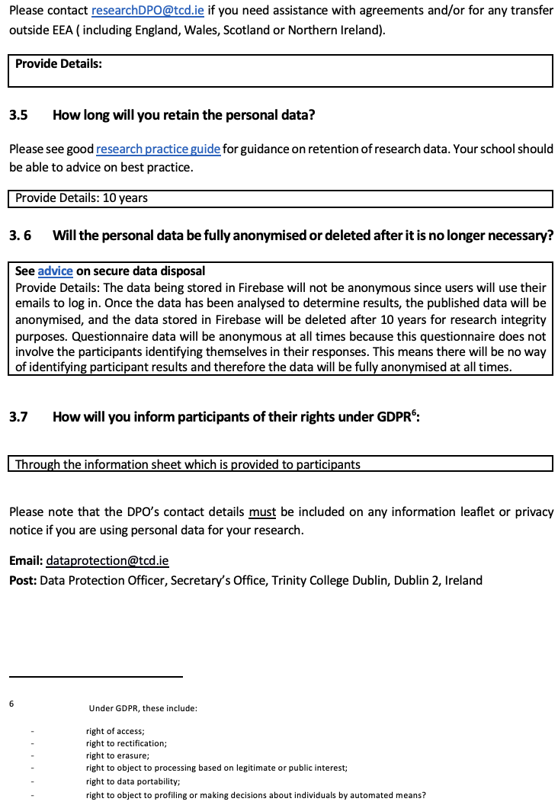

Figure : Ethics proposal part 4.

## **Questionnaire Before Using Application**

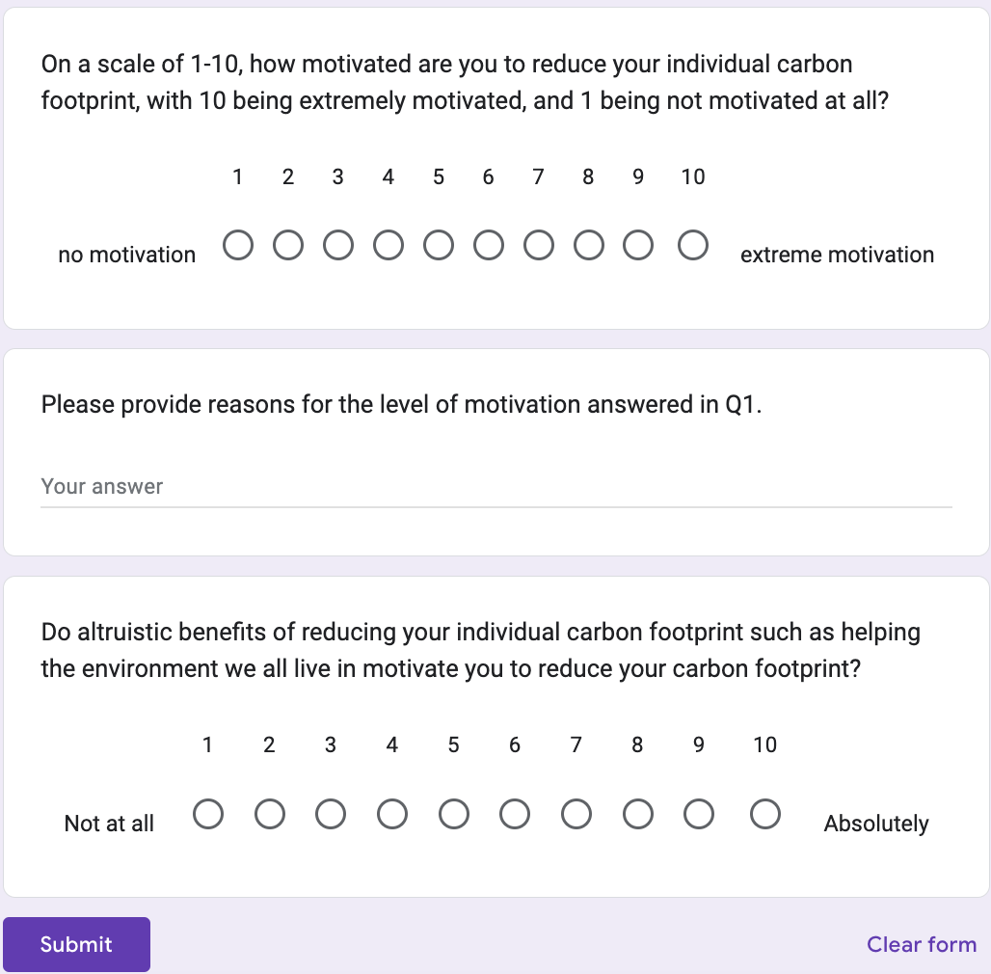

Figure : Questionnaire before using the application.

## **Questionnaire After Using Application**

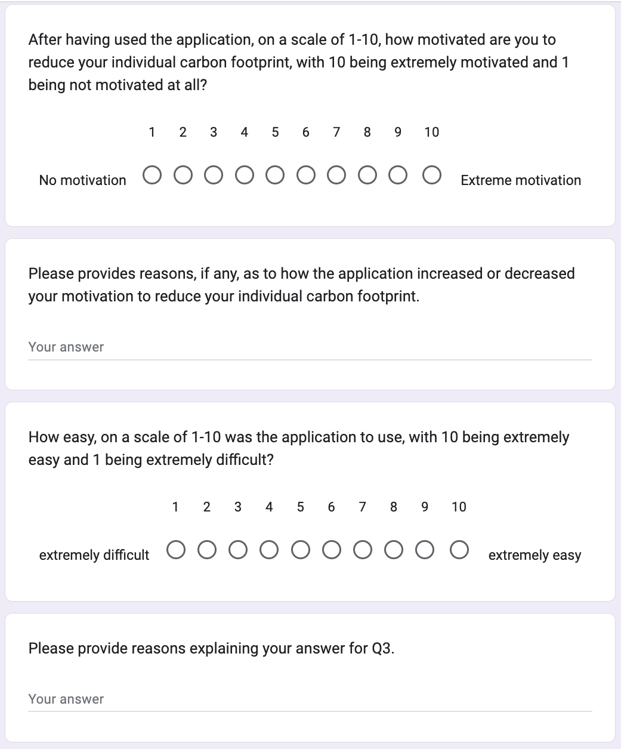

Figure : Questionnaire after using the application part 1.

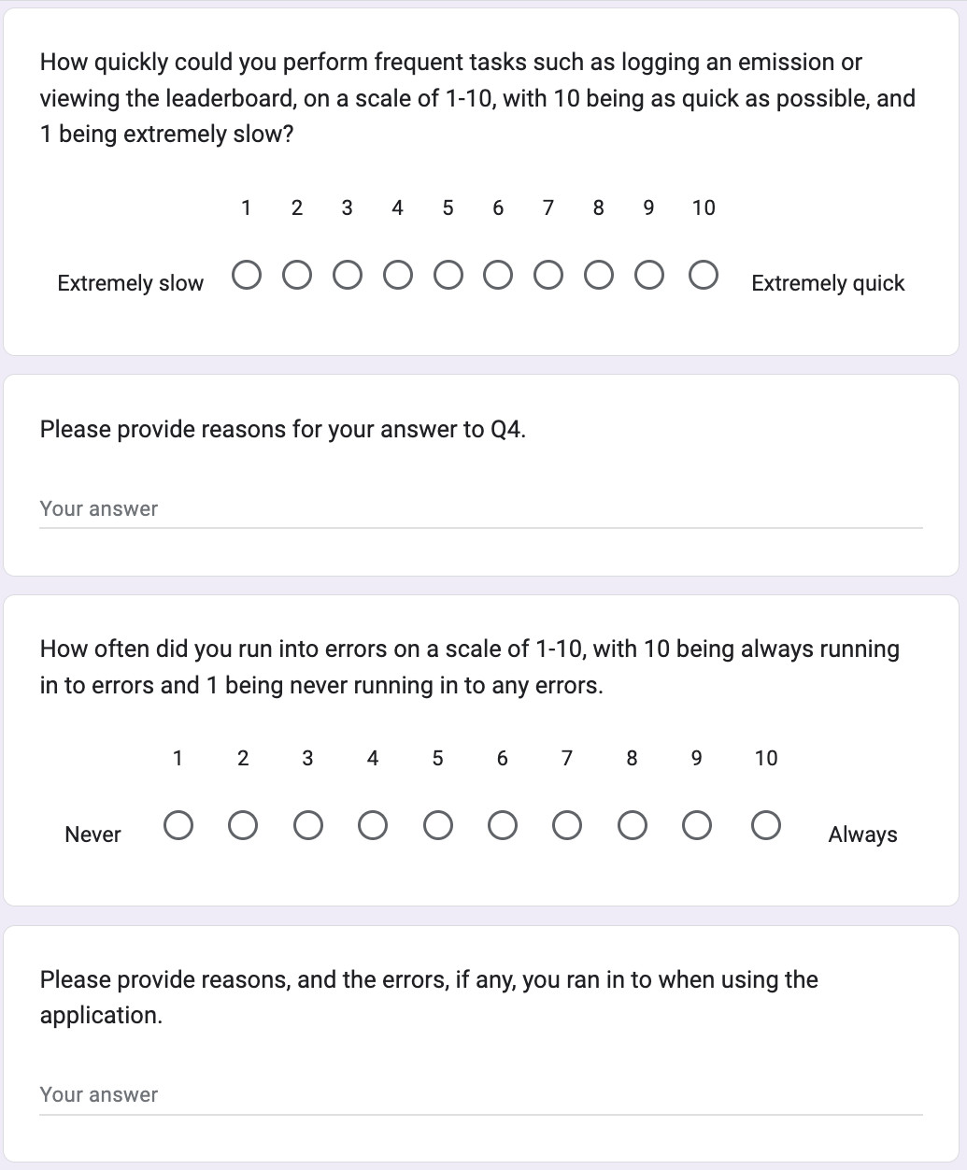

Figure : Questionnaire after using the application part 2.

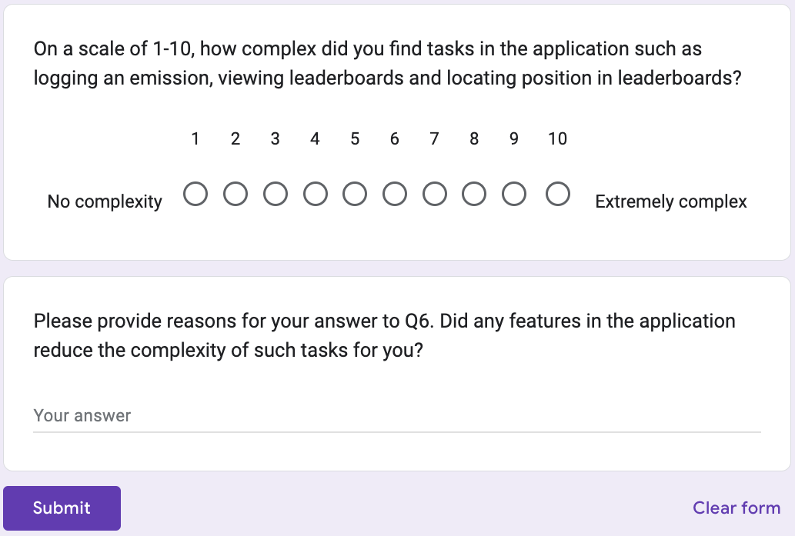

Figure : Questionnaire after using the application part 3.